CLIENT: Ian MacColl
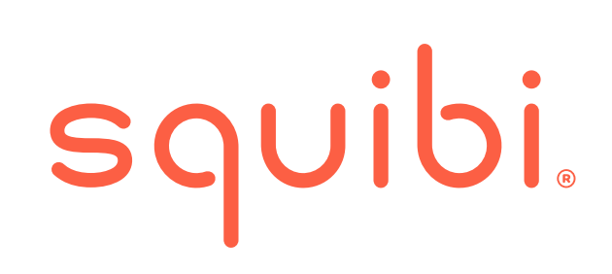

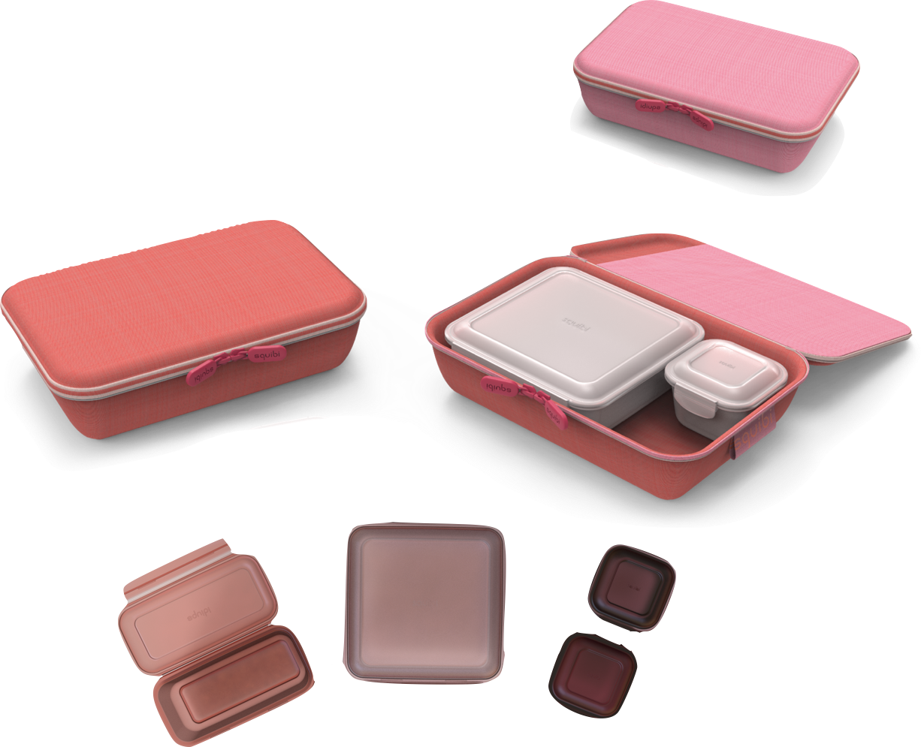

Andres Resendiz Gonzalez
Brian Abellera
Morgan J. Hopper
Sameera Yerramilli

Business Models and Stakeholders, Spring 2019

30th April 2019
Table of Contents
Executive Summary 2
Current Situation 3
Our Understanding of the Client’s Objectives 6
Our Recommended Approach 9
Deliverables and Benefits 13
Summary and Next Steps 23
Consulting Team Bios 24

Executive Summary
Squibi is a startup company in the San Francisco Bay Area focused on providing safe and thoughtful systems that bring efficiency to young millennial families by responding to their unique needs.
Over the next three years, Squibi’s vision is to capture a global customer base via online platforms with a minimum target revenue of 5 million US dollars. Below is a proposal to concurrently deploy two unique product lines.
Envisioning a new path
We determined how a single product approach presents a single-point-of-failure risk where Squibi’s success may hinge on a single effort. This risk becomes more pronounced when considering brand awareness creation amongst a crowded market, costs, and strong competitors with significant market share. We assess that a two-component diversified approach in a product, market demographics, and channel may lessen risks presented by the single product approach. :
- Low-risk product line on Amazon → focused on generating cash flow, volume, and standup business operations
- Innovative product line on Kickstarter → focused on market testing millennial family solutions

The Current Situation
Background
Ian Coats MacColl works as an industrial designer and product developer who stands at the intersection of design, brand, and implementation. He is most recently Chief Creative Officer at Green Toys where he led the creative process for both product development and marketing communications. Green Toys makes the highest quality toys in the industry from recycled materials manufactured in the USA.
Ian was previously the vice president of design at Perfect Fitness where he had responsibility for the look and feel of all brand touch points including product development, packaging, web, and print. Perfect Fitness is a consumer products company making high-quality solutions around the functional movements of the body.
Before Perfect, Ian was vice-president of Research and Design at Wham-O, a toy company located in the San Francisco Bay Area, where he managed the development of brands for Frisbee, Bogey, Super Ball, and Hula Hoop. He ran his own design consultancy for 10 years with clients including Target, Mini, and Camelbak and was the managing director of IDEO San Francisco, a product development consultancy.
Ian is an Associate Professor of Industrial Design at the California College of the Arts in San Francisco and has taught in the program since 1992. He received undergraduate degrees in Thermodynamics from Brown University in Providence Rhode Island and in Industrial Design from Art Center College in Pasadena California. His work is in the permanent collection of the New York Museum of Modern Art and has received numerous professional accolades including IDSA Gold and the Red Dot awards.
Artoy Ltd. is a family owned and family oriented ODM manufacturer. The company specializes in high-quality educational toys and accessories for children to learn and play at the same time. Artoy has been in the toy manufacturing business for over 35 years. The office headquarters are located in a 15,000 sq.ft. office in Lai Chi Kwok and Artoy has a separate 2000 sq.ft. Showroom in Tsim Sha Tsui.
Artoy’s factories are located in Dongguan, Guangdong. The 300,000 sq. ft. facility holds over 60 injections and blow molding machines that are capable of producing 80 - 600 tons of material. The factory is broken down into 10 departments:
General Office
Engineering Department
Assembly Department
Injection Department
Blow-Moulding & Extrusion
Painting Department
Tooling Department
Ultrasonic Department
QA & QC Department
The Warehouse

The Chan Family, the owners of Artoy Toy MFG, are based in the SAR of Hong Kong. Family members include Raphael, Teresa, Sharon, and Stephen. Sharon is the co-creator of Artoy and as a young mother of two, she embodies the customer segment to which Sqiubi is tailored.
Immediate Vision
Within the next 3 years grow Squibi into a $5M pan USA Company providing safe & thoughtful systems that bring efficiency to young millennial families by responding to unique needs.
Development
The founder Ian has developed prototypes of “Flatpack” product line and with his team of design students from CCA. Together, they have co-created versions of look and feel of this product line after deep market research. In addition to that, “Flip”, a patent-worthy product designed by Ian, is under development and refinement at present.
These two product lines are proposed to be the products at launch and Squibi aims to become profitable with these product lines within 2 years of their launch.
Planning
In order to become profitable by 2020 with the above-mentioned product lines, Squibi at present targets to launch these products by the end of the year, sell them completely online on Squibi.com and Amazon.com and use 3rd party fulfillment (specifically Amazon’s fulfillment).
For this to be possible, there is a potential deal ready to be signed with Amazon. In terms of tooling, manufacturing, and shipment, Artoy’s infrastructure is readily available for the production of “Flatpack” product line, however, “Flip” product line still needs a runway for development.
Status quo Business Model Canvas-
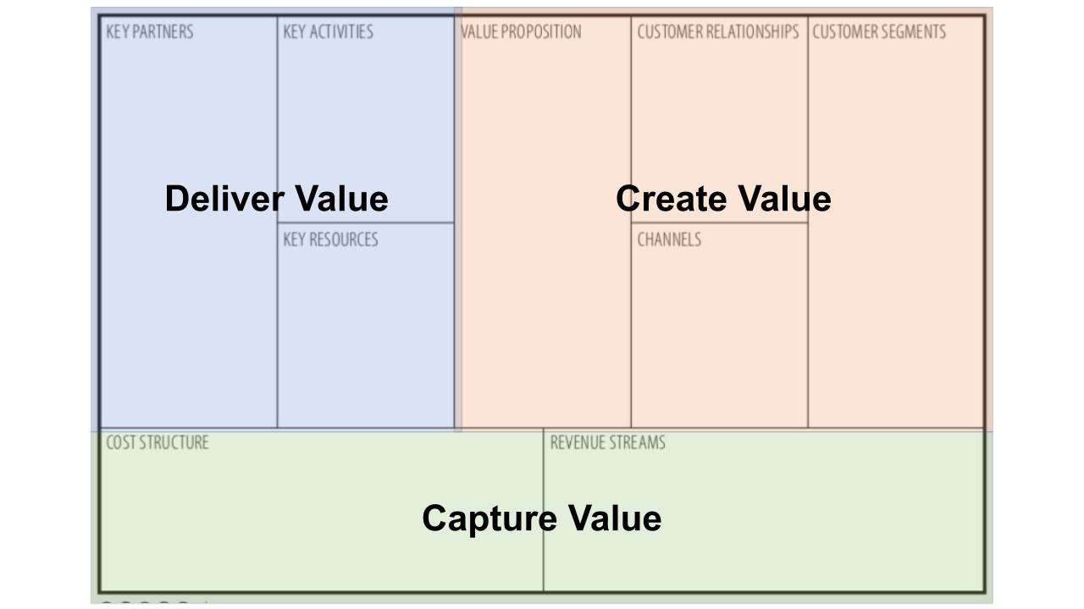
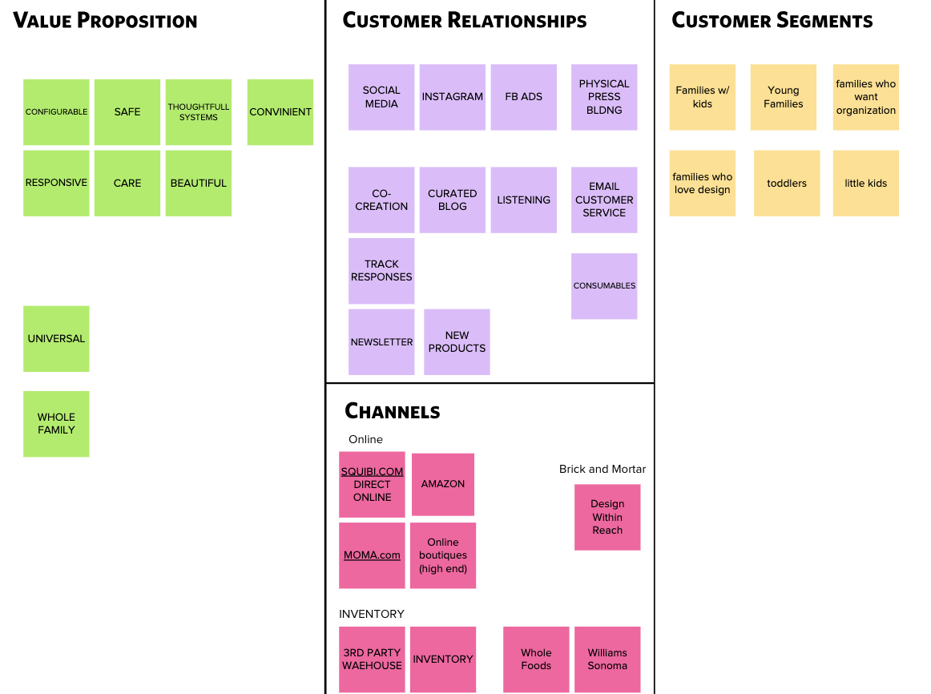
Create Value

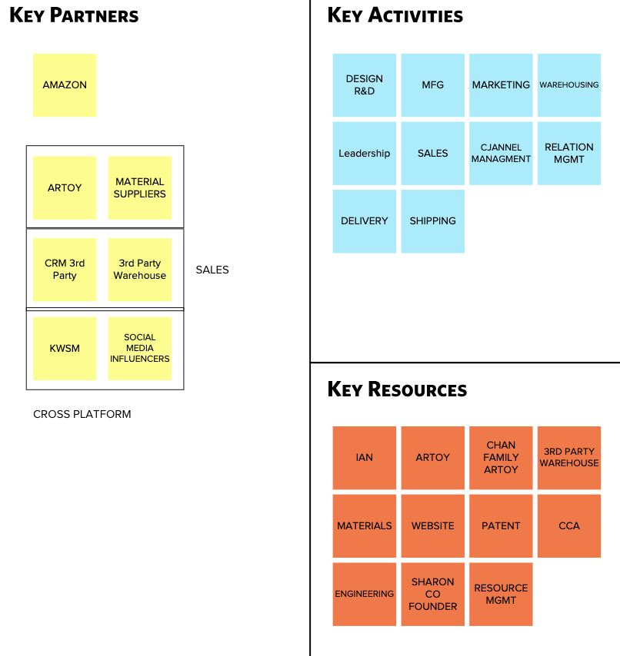
Deliver Value

Capture Value
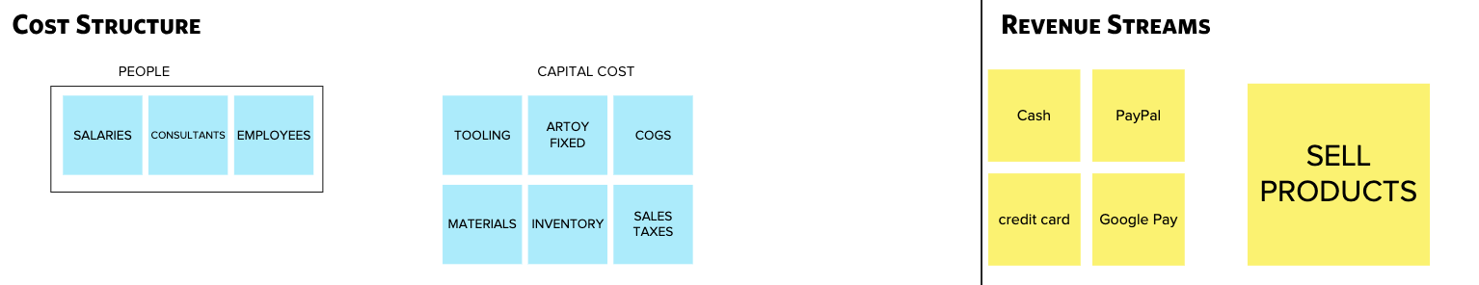

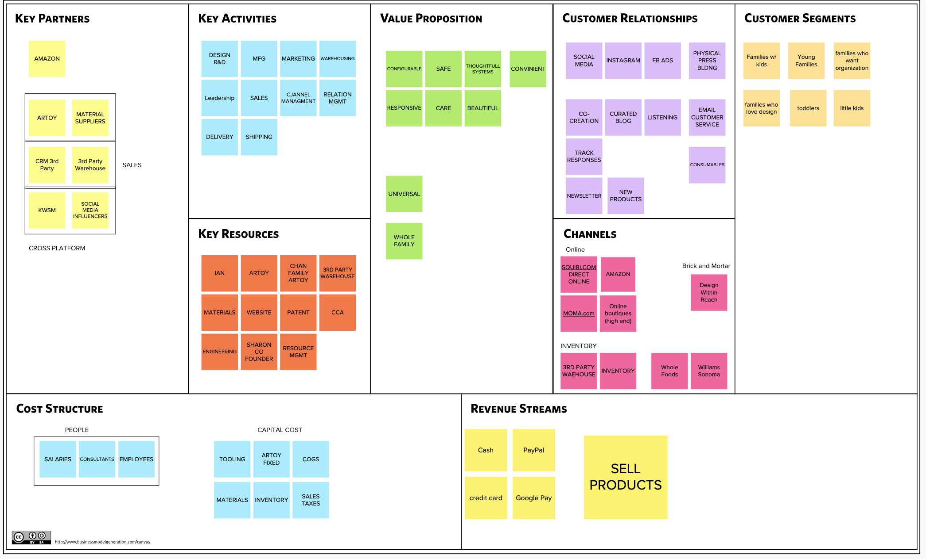
Status Quo Business Model Canvas

Our Understanding of the Client’s Objectives
Squibi was first introduced to the team as a food storage and bathroom solutions startup company. Convinced that the founder’s objectives were much deeper than the aforementioned descriptor, the group collectively identified that Squibi’s overarching objective is to:
Provide safe and thoughtful systems that bring efficiency to young millennial families by responding to their unique needs
Further framing this objective, Squibi aspires to capture the global market over the next three years with a minimum target revenue of 5 million US dollars.

When asked about Squibi, we provide the following encapsulation:
We care. Everything we do is for families, by families.
We strive to simplify life's beautiful messiness, perfect the clutter, and embrace the unplanned. We do this by making high-quality, well designed, and user-friendly products for little hands, big hands, and everything in between.
Reclaim your household, create space for time, and invest in the priceless moments family brings. Squibi, grow with us.
When asked about WHO Squibi is, we share that:
We are an environmentally and socially responsible community of designers, innovators, and entrepreneurs. In everything we do, we aspire towards solutions that are sustainable and environmentally viable.
From our raw materials to our building processes, we ensure our efforts reduce environmental impacts. It is our corporate responsibility to take care of all Squibi employees and ensure our products are produced under safe, fair, and humane working conditions across our supply chain.

Squibi’s objectives are deeply rooted in its founder’s personal experiences. As a father of two, Ian identified challenges and competing paradigms between his parental role and professional / pre-parent lifestyle. Ian’s pre-parent lifestyle of organized professional focus, resource control, and prioritized time management was now at odds with the parental duties associated with two children. Ian is now required to mentally oscillate continuously between professional obligations, providing for his children, and take care of himself. Self-described as an entropic lifestyle where one must operate in the unstructured and unorganized, Ian conveyed frustration and exhaustion. In contrast, Ian further conveyed that within the chaos, he found beauty and perfection through experiences shared with his family. Amidst all the chaos, Ian found “perfectly imperfect” moments which made the lifestyle shift worthwhile.
Enter Squibi. Ian hopes Squibi’s product lines will serve as a support structure to millennial parents, enabling users to find and create special moments with their children before time fades, opportunities are missed, and regrets are formed. Squibi is focused on being that helping hand in moments of need enabling the unnecessary to fade away, leaving the perfectly imperfect to shine.
Alongside Ian, we identified a unique and clear-canvas opportunity to shape a startup from the ground up, form its baseline existence around ideas, ethos, and purpose, and develop a brand whose product line knows who they are, why they exist, and how they intend to deliver their message to its customers. It’s stewardship this team takes with great humility and excitement.
Everything begins with an intense understanding of the millennial parent (Squibi’s customer base). This core understanding would then lead us to understand their unique pains and desires which ultimately lead to clarity required for Squibi to build their brand and products towards relieving such pains and value creation.
Defining the millennial parent within a customer role and leverage within a business context was extremely difficult. After multiple workshops, we deconstructed the millennial parent customer into six roles. We operated under the assumption that Squibi’s target customer desired mastery in these six roles, must dynamically assume these roles as the situation dictated, and carry multiple roles concurrently:
1. | Caregiver | primal, survival, food, clothing, shelter
2. | Nurturer | love, attention, support, acceptance
3. | Homemaker | maintain, order, structure, community, team
4. | Guardian | protecting, safety, reliance
5. | Teacher | academics, life skills, ethics, independence
6. | Leader | discipline, rules, direction, accountability

We identified over 20 pain points associated with the aforementioned roles (frustration, stress, thankless, etc.). Further analysis revealed that these pain points were symptoms of four key categories (problems):
1. | Drain | expensive, time-consuming, wasteful, illogical, unhealthy, shortcuts
2. | Environment | tired, frustrated, stressful, anxiety, helpless, sacrifice w/o compromise
3. | Mental Toll | entropic, fleeting, cluttered, never-ending, treading water, unfinished
4. | Losing Battle | no manual, trial and error, thankless, the ‘bad guy’, failure feeling

Congruently, we identified over 20 desires associated with the aforementioned roles (clarity, productive, rewarding, etc.) further categorized in four areas (desired value):
1. | Structure | control, enabling, clarity, prioritize, consistent, flexible, agile
2. | Feeling | caring, time for the important stuff, harmony, togetherness
3. | Being Present | immersive, moment savoring, loving environment, quiet stillness
4. | Accomplishment | thrive, reward, productive, logical, accepting, teamwork

The above is Squibi’s lighthouse. As Ian navigates and decides what product(s) to launch in the next year, an unwavering focus on the above will entrench Squibi’s identity. And when successful, the deployment of future product lines will convey a thoughtful and ecosystem-like approach, themed consistency, aesthetic, and exemplify to the millennial parent that Squibi ‘gets it’.

Our Recommended Approach

We propose a three-phased plan distributed across three years beginning in 2019 and ending in 2021. Within a strategic sense and with the assumption that Squibi remains malleable to adjust to market conditions and user feedback, the phases are:
- Phase I (present/2019). Online brand awareness establishment and Squibi business/production infrastructure creation
- Phase II (2020). Global online sales deployment, infrastructure refinement, and scaling preparation
- Phase III (2021). Leverages Phase I-II’s learnings and data to deploy a multi-product global sales presence
Across all three phases, we propose strong adherence to the aforementioned vision, mission, and approach. Squibi must stay mindful that the tactical grind to establish marketing, production, and deployment may detract and obfuscate the strategic goals resulting in unfocused efforts and lost resources. Below are strategies, aligned with Squibi’s ethos that may balance these instances:
- Remember Why. Squibi’s focus is to provide millennial parents with thoughtful systems, not food storage products
- Sell WHO we are. Squibi is an environmentally and socially responsible family-owned business that gets you (the customer)
- Local to Global Approach. Despite online global customer reach at outset, cement North American brand recognition first and leverage to build a global brand
- Use What We Have. Via Artoy and Chan family, Squibi has unique advantages over other product startups via production, logistics chain, and expertise infrastructure
- Online Only. Online reach equals lightweight customer reach versus conventional brick and mortar product deployments
- Effective Communication. Target and attract via existing social media channels actively utilized by millennial families
- Innovation Through User Feedback/Interaction. Squibi differentiates itself by listening to its customers and conveying empathy via their product. Proactively pursue such interaction and convey to customer a sense of care and ownership of Squibi

PHASE I- ESTABLISH PRESENCE
Phase I’s (2019) quarterly measurable objectives are as follows:
- Q2 and Q3. Deploy and aggressive pre-launch Squibi online marketing and brand awareness presence
- Q4. Design and establish a launchable suite of of products
Phase I’s key performance indicators may be measured against Squibi leadership’s ability to answer the following:
- Does Squibi possess a noticeable online presence?
- Is Squibi receiving concept feedback from future target customers?
- Is Squibi actively being discussed on social media, online forums, and influential channels?
- Is there a sense of ‘buzz’ and anticipation from future customers?
- Does Squibi have a refined launch product aligned with Squibi brand intentions?
- Is Squibi aligned with Artoy, the Chan family, logistic components, and online sales channels to produce, deliver, and deploy product in Q1 2019?
PHASE II- LAUNCH SALES
Phase II’s (2020) quarterly measurable objectives are as follows:
- Q1 and Q2. Begin online sales via Amazon.com and Squibi.com (U.S. market focus); expand online presence incorporating user feedback channels
- Q3 and Q4. Establish U.S. market brand recognition; proactively deploy an aggressive pre-launch global brand awareness and online marketing campaign
Phase II’s key performance indicators may be measured against Squibi’s leadership ability to answer the following:
- Is Squibi generating revenue via Kickstarter and/or Amazon?
- Is Squibi actively soliciting, reviewing, and incorporating feedback into production and product?
- Does Squibi possess the personnel capital necessary to sustain and grow?
- Is Squibi developing business practices and processes to support Phase III scaling?
- Is Squibi aggressively leveraging U.S. based brand recognition to expand online global presence?
- Does Squibi possess a noticeable global customer online presence?
- Is Squibi receiving concept feedback from future global target customers (Asia, Europe, etc.)?
- Is Squibi actively being discussed internationally on social media, online forums, and influential channels?
- Is there a sense of ‘buzz’ and anticipation from future global customers?
- Does Squibi have global launch products aligned with unique needs of global customers (i.e. compatibility with european and asian refrigerator and cabinet measurements)?
- Has Squibi attained a minimum break-even financial state?
PHASE III- SCALE
Phase III’s (2021) quarterly measurable objectives are as follows:
- Q1-4. Leverage US brand recognition, infrastructure, and profits to expand globally
- Q4. Double US based sales
Phase III’s key performance indicators may be measured against Squibi’s leadership ability to answer the following:
- Is Squibi efficiently using data to drive customer awareness, product placement, and sales?
- Is Squibi adjusting to a global customer base and efficiently identifying and incorporating common and unique needs into products?
- Anticipating Squibi sales have increased in volume, is Squibi actively working to widen margins leading towards profitability?
- Is Squibi profitable, sustainable, and increasing in brand recognition?
- Is Squibi staying true to their vision and mission?
- Is Squibi seeking ways to evolve alongside its customer base, reviewing its core business practices, and staying current on market trends to remain in the innovative business space?
IMMEDIATE STEPS
Given Squibi’s aggressive posture to launch sales within eight months (May 2019-January 2020), we recommend the following immediate action plans:
- Establish Leadership Presence, Stewardship, and Structure
  - Hire a dedicated staff focused on:
    - Leadership
    - Administration
    - Design
    - Marketing
    - Production
    - Sales
    - Legal
    - Financial
  - Identify, acquire, and deploy automated business management solutions
  - Establish and implement leadership and administrative processes, standard operating procedures, and practices. Educate staff and present centralized body of knowledge to entrench Squibi culture within vision and mission
  - Actively manage investor relationships by bringing them into the creative process, cadenced business meetings, and proactive interactions focused on strong communication lines
- Announce Squibi’s Arrival
  - Develop a brand awareness strategy
  - Develop and deploy Squibi website, social media campaign, and endorsements/partnerships
  - Establish online sales and delivery channels with Kickstarter and Amazon to lay groundwork for Q1 product deployment
- Produce
  - Design, prototype, test, and finalize first product(s) for Q1 2020 launch
  - Actively work with Artoy to activate production infrastructure, deploy processes, test methods and workstreams, strengthen quality controls, and equipment testing in preparation for Q1 2020 production activity
  - Seek pre-launch user testing and validation cohort. Test production items with enough time to make changes per user feedback
- Sell
  - Establish administrative foundation to deploy products by ensuring legal approvals, licensing, copyright, and trademark requirements are met
  - Define immediate supply chain logistics, timeline, and costs required for Q1 2020 launch
  - Establish online sales infrastructure(s) for Q1 2020
  - Determine/procure/lease distribution centers and delivery mechanism
  - Define supply chain logistics, timeline, costs, and identify scaling requirements to accommodate 2021 launch global launch

Deliverables and Benefits

Our final project deliverables include:
- Recommended One Page Business Plan.
- Mission Statement
- Vision Statement
- SWOT analysis on current model
- Discussion Guide for further exploratory research
- Story Telling Canvass and Customer Discovery Story
- Financial Analysis / Payback Model
- Three alternative business model options with topline pros and cons for each
- A Business Model Canvas recommendation along with a timeline of implementing several Canvases
- A Formal Presentation Deck
- Written report
- Presentation to Artoy (optional)

Timeline

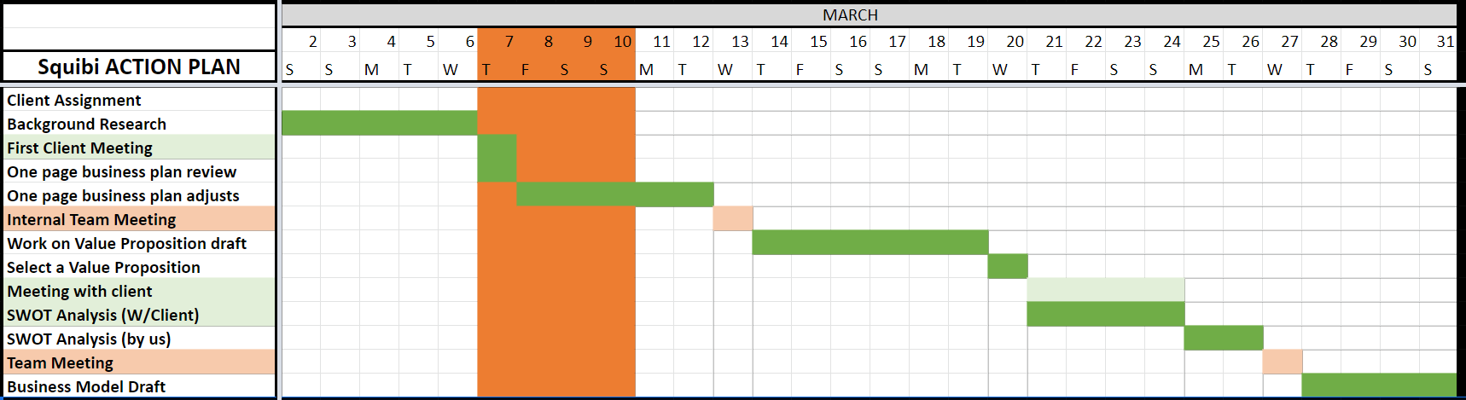
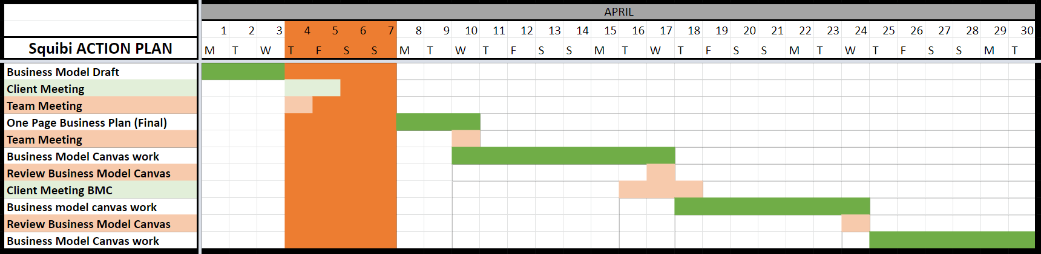
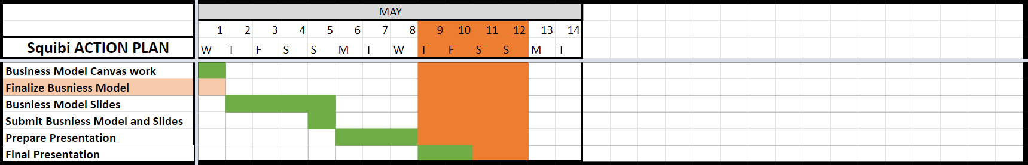

Resources
Tools
One Page Business Plan - Jim Horan
A tool that concisely communicates a companies business plan. The OPBP contains five sections: the vision, the mission, company objectives, strategies, and action plans.

Business Model Canvas
A tool that enables an entire business model to be visually represented on one page. The canvas has nine interconnected building blocks: value propositions, customer segments, customer relationships, channels, key partnerships, key activities, key resources, cost structure, and revenue streams. This tool was used to represent the Squibi’s proposed business model and to workshop the three alternative business models.

Texts
Business Model Generation - Alexander Osterwalder and Yves Pigneur
The text outlines how to use the Business Model Canvas for innovation of new business models in a simple, yet holistic manner.

The Startup Owner's Manual - Steve Blank and Bob Dorf
A step-by-step guide to building a scalable startup. This text provided supplemental guidance to building a Squibi, along with practical considerations when evaluating practices and courses of action for Squibi.

Design a Better Business - Patrick van der Pijl, Justin Lokitz, and Lisa Kay Solomon
A text that focuses on the design elements of business generation and how companies can leverage design thinking and effective workshopping to build products and businesses that focus on addressing the needs of the customer.

People
Tim Smith
Our work with Squibi was initiated and guided by Professor Tim Smith. Tim is the Associate Chair and Associate Professor for the MBA in Design Strategy program at the California College of the Arts. Tim provided lectures, materials, financial analysis, and specific guidance for this project.

Project Goal

Our goal for this project was to develop business model options and to provide advice to Squibi for not only the launch of the initial product, but also advice on how to operate the business and for tactics for continued growth. The models and suggestions proposed were designed to fall in line with Squibi’s objectives and commitment to running a sustainable business.

At the outset of this project Squibi’s greatest needs were to offer a product that has a clear value proposition that is inherently different from the current offerings on the market. In tandem with this, it Squibi needs to reach the target market effectively and is able to sell at margins that will provide a sufficient return in two years. Lastly, in order to succeed Squibi will need additional staffing to bring the product to market, to handle sales/fulfillment, and to develop/ implement a more robust marketing strategy. The models proposed below provide a road map for how Squibi might accomplish these goals.

How Our Team Worked With Squibi
Our team initially engaged with Ian in late March. Prior to our initial meeting we conducted background research on Ian’s previous work in product design and management (Perfect, GreenToys, Whammo, IDEO etc.) and his philosophy on product development and manufacturing.

In our initial meeting, Ian provided:
- An overview of Squibi and proposed product lines
- Exploratory primary research that Ian conducted on young families across different geographies.
- An initial run of the projected finances for the project
- Background on funding including details on Artoy and the Chan family.

In this meeting, our team provided:
- Background on our members and the relative strengths that Squibi would be afforded based on our previous work.
- Detail what our team would be able to provide to Squibi in terms of deliverables.
- An outline of our timeline.
- The general reason and methods for workshopping different elements of our deliverables.

After this initial meeting we set up a series of internal and collaborative meetings along with target dates for all work. We set up several repositories to share information and assets with Ian and established modes of communication and available hours. We made ourselves available to Ian for additional consulting on an as-needed basis which included advice, meeting with investors, and other requests directly or indirectly related to Squibi.

Business Model Canvas Alternatives

Kickstarter
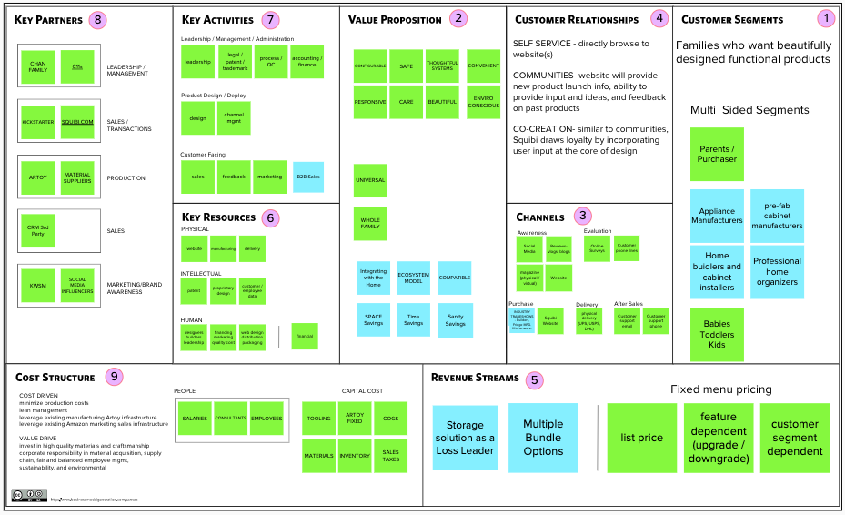

Storage Concept.
Squibi Flat Pack is a well designed product with functionality in to account. This is a product thinked to work effectively and to maximize the space around the home. This is why in this model we see a possibility of creating specific products that work with the current storage solutions implemented in a home.

Value Proposition
The value proposition for Squibi Flat Pack would not change. The values of the actual product might need to be fine tuned to match the idea of maximizing space and utilizing every inch of storage compartment.

Customer Segments
Young families with a taste for well designed products and functional.
A new customer for this concept are manufacturers and builders of storage systems for homes. Appliance manufacturers, cabinet makers, professional organizers and hoome builders.

Customer Relationships
The relationship is built on a self service model, via the website and social media. At the sametime the website and social platforms have the purpose of creating a community for announcements and feedback from customers.
The idea of receiving feedback is to co-create with customers better solutions for their current needs.

Channels
The initial channels have different purposes from awareness with social media, blogs, magazines and the website fulfilling this tasks. Purchase can be done via industry trade shows or through Squibi’s website. We are assigning delivery to existing logistic professionals like UPS, USPS or DHL

Two more channels will be dedicated to customer support and after sales contact and for evaluation and customer feedback .

Key Partnerships
Our keyparnters will be acording to the diferent areas of the company.
Leadership would be done by the Chan Family and C11’s as posible management.
For sales and transactions we are relying on Kickstarter for next rounds and squibi’s website as well as 3rd party CRM’s.
Marketing will be done by our communication partner (KWSM) as well as social influencers.

Key Activities
The key activities depend on leadership, management and administration speaking about process, legal matters, acounting and finances
Design would be conducted by a design department lead by Ian.
Sales would be don by a specific channel on our website.
Key Resources
The key resources will be divided in three main categories: Physical, Intellectual and Human.
Physical: out website, the manufacturing force and the delivery companies
Intellectual: our patents, designs and customer and employe data.
Human: designers and builders, the administrative team as well as our web team.

Cost Structure
The expenses to run Squibi would come from the Chang Family on the initial investment. Running the company would involve the salaries of the different teams, the fees of consultancies and the recruitment and retention of talent.
Additional costs would be assigned to the manufacturing process.

--------------------------------------------------------------------------------------------------------------------

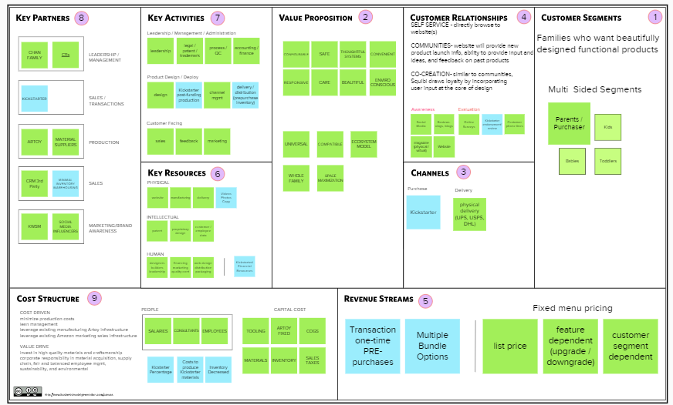

Kickstarter Concept
Squibi Flat Pack is entering into a saturated market (over 90,000 food storage solutions exist on Amazon currently). Flat Pack is, however, a somewhat novel product offering in its stylish modular design and its focus on environmentally and socially responsible practices. Though secondary and exploratory primary research has been performed, it is still unknown if there is sufficient market demand for such a product
In addition to this, as of this writing, it is still unclear if the Chan family will decide to greenlight the product due to the risk of not recovering the capital in a sufficient amount of time. Lastly, the current payback model indicates that it would take over 5 years for the Chan family to see a return on the investment.
If Squibi were to raise the capital needed to start the business via Kickstarter all three aforementioned concerns would be put to bed.

Value Proposition
The value proposition for Squibi Flat Pack would not change. The funding for the product has changed, but not the product itself. One important caveat here is that the values of the existing product may need to be tweaked slightly to help it to stand out from other products seeking funding. Many of the values propositions of successful Kickstarted products surround newness and novelty over things like practicality and usefulness. Squibi Flat Pack has elements of all 4, but would likely need to emphasize the former rather than the latter.

Customer Segments
No change in the core demographic of young families. Due to the nature of the channel, however, the segment would be a subsection of this group; one who uses Kickstarter with some regularity, and finds a deep need for the value propositions that Flat Pack offers.

Customer Relationships
To the existing components of the customer relationship, the responses to questions via Kickstarter and the management of customer reviews would be added.

Channels
The initial channel would be 100% Kickstarter pre-orders. In theory, Squibi could sell via its own website, but additional capital might be required to do so and the point of using Kickstarter would be defeated. Subsequent sales (Post kickstarter) would be by the same channels as discussed in the base model (possibly without Amazon).

Key Partnerships
Kickstarter would be added as a key partner.

Key Activities
No activities would be added, but the production and distribution would change to reflect how the Kickstarted product was sold (e.g. production batch, and production timelines changed).

Key Resources
Though these resources were part of the baseline model, the video, photos, and copy for the Kickstarter now become a key component of the new model. High production value along with concise yet engaging content will be paramount for the funding of a successful campaign. Ian might be able to leverage his networks at CCA to produce such content at a reasonable cost from current students.
The capital resources required from the Chan family for the launch of Squibi is cut drastically - successful Kickstarter campaigns can be run for less than $10,000.

Cost Structure
The expenses in operations to run Squibi remain largely unchanged. The source of the capital moves from the Chan family to the Kickstarter funders (less the costs associated with initiating the Kickstarter). The indirect costs of the capital (interest, equity, opportunity costs) would be completely eliminated.
It is worth noting that Squibi would need to account for the 5% service fee and the 3% transaction costs that the company would incur on their total amount raised if they are successful in their kickstarter campaign.
---------------------------------------------------------------------------------------------------------------------
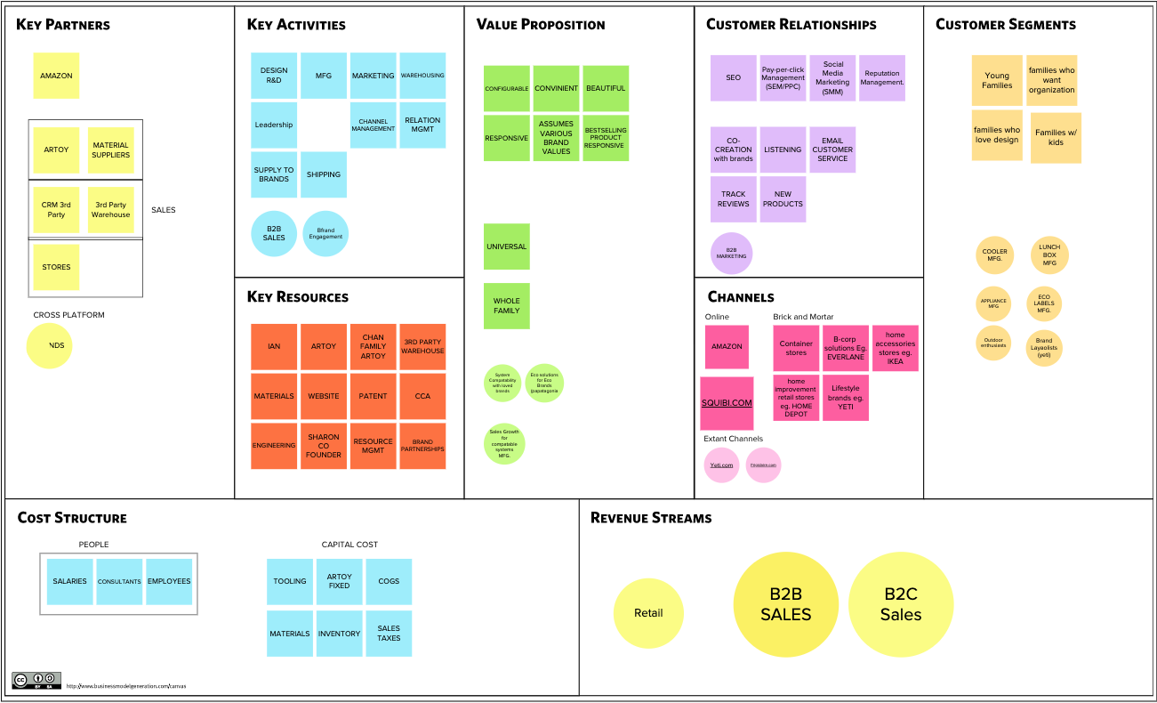
Squibi Compatibility or White Label Concept
As mentioned earlier, in order to reduce the single-point-of-failure risk of launching and relying on one line to generate revenue, we propose launching a second independent product line bearing low risk and focused on generating cash flow, volume, and ease into establish business operations.
Via Amazon, vendors currently food storage items such as coolers and lunch boxes. And an overwhelming pain point is the inability to utilize the entire interior space due to food storage components that do not fit perfectly.
This proposed Squibi Compatibility line would provide food storage solutions specifically intended to fit the internal measurements of the most popular coolers and lunchboxes on Amazon. By leveraging Amazon’s analytics backend, Squibi would identify the top grossing items to build towards and use Amazon’s search and results feature to advertise compatible food storage products for the highest selling coolers and/or lunchboxes.
We believe that the “magic is in the measurements” and Squibi’s products would enable customers to maximize their coolers and lunchboxes purchased via Amazon.
Value Proposition
This option does not change the Value Proposition. Rather, it builds upon the status quo BMC by incorporating value to fans that Squibi partners with and may add an eco-friendly solution with partnered brands.

Customer Segments
No change in the core demographic of young families.
If Squibi intends to self-brand this line and leverage Amazon’s search and results feature, there would be no change to the Value Proposition given theat Squibi is selling direct to consumer.
However, if Squibi intends to pursue a white label concept where their products would be marked with another brand, the Value Proposition would change as they would be shift to a business-to-business model.
Customer Relationships
In addition to the customer relationships cited in the status quo BMC, business-to-business would be added if Squibi pursues the white label concept.

Channels
While this option assumes all of the previous mentioned channels, a business-to-business components may result in Squibi products being sold on partner brands’ websites (i.e. Yeti.com, Thermos.com

Key Partnerships
Partner brands would be added as key partners.

Key Activities
In addition to the other BMCs’ key activities, this effort would include business-to-business sales and brand partnership building.

Key Resources
Key resources will not change.

Cost Structure
Cost structure will not change.

Revenue Streams
Business-to-business revenues and retail revenues will be added to revenue streams.

Next Steps

We believe there is a way of interconnecting the three Business Models and develop them on a period of time as a single one.
The BM plan would start with the development and foundation of the company. The different teams and areas need to be created and assigned. Leadership would be by the Chan Family as well as Ian.
At the same time as we build the company, brand awareness should be initiated. Different initiatives like social media presence (facebook, instagram) as well as web presence (Squibi’s website) will build the foundation blocks for this.
During this process, the design, testing and perfecting of our initial products can take place, this way we will be prepared and ready to launch a kickstarter campaign with a tested product and its different iterations.
Once we have tested, develop and founded a first batch we can go to market with an initial product to start building the squibi consumer.
While the first batch is seling, we can integrate and develop the next phase or product line. We suggest the white label that works with partners like yeti or coleman, the storage system that partners with cabinet builders and home developers ad lastly, develop additional line of products like bathroom or kitchen lines.

once those products have been designed and tested, we can run a new founding round in kickstarter and found the different lines of products. This is a process that can be repeated every time that we think about launching a new line of products or a specific one.

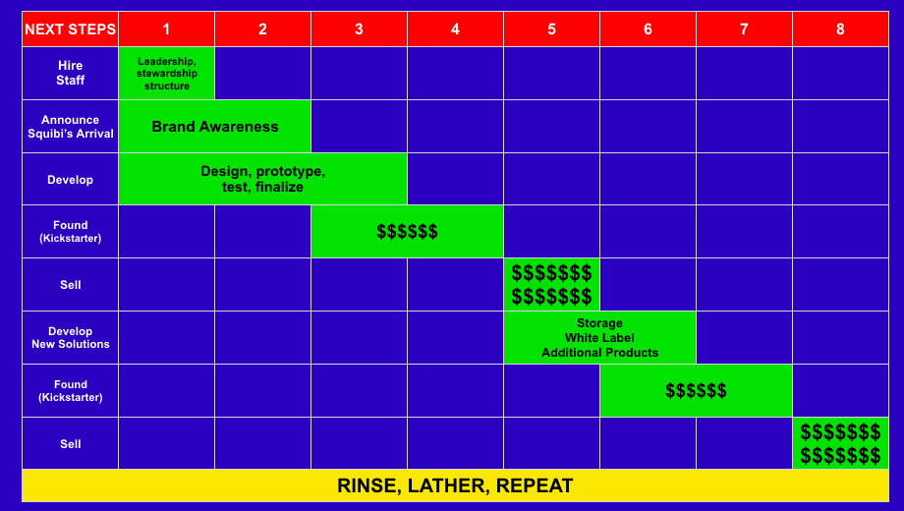

Consulting Team Bios

Andres Resendiz Gonzalez
Strategist, designer and forward thinker with over 9 years of experience working with major international companies in several sectors developing projects of innovation, strategy, branding, brand culture, and environmental design. Possessing a design oriented and curiosity-driven approach, Andres is part of a multidisciplinary team in Mexico City creating agile brands and strategies for an ever-changing and fast-paced environment.

Brian Alberra
Accomplished strategist and operations leader, with over 18 years of international experience in volatile environments, delivering quantifiable results in terms of strategic impact, transforming operations, and leading elite teams. A champion of change with a demonstrated history of accelerating success via innovative approaches, risk adaptation, leadership development, and organizational change within the military, intelligence community, and private sector. An award-winning leader with three masters degrees and deep operational experience in high-stress environments, Brian currently leads a team conducting dynamic national security operations.

Morgan J. Hopper
A specialist in developing a strategy in domestic and international markets - possessing over eight years of experience in startup development. He managed projects in excess of $600M and developed products that generated a revenue of more than $70M per year. Prior to his work in strategy, he attended Hong Kong University as a doctoral candidate. He subsequently worked as a researcher in areas that include cross-cultural psychology, prosocial behavior, neurology, and interpersonal dynamics at U.C. San Francisco, Hunters College of New York, U.C. Berkeley, U.C. Davis, and Stanford University.

Sameera Yerramilli
Design strategist and business development and sales expert. A passionate entrepreneur with a demonstrated history of leading teams to develop scalable and repeatable business processes from scratch. Within agile environments, incorporates creativity into the daily innate problem- solving, managing complex client escalations, sales negotiations, and growth hacking.

PAYBACK MODELS

For Squibi we had the luck of having Ian work on a very detailed and complete document that showed its initial forecast for payback and ROI.

This document showed the numbers for multiple products and considering launching squibi via its own website. However, during team meetings and conversations Ian and the team realized we had several opportunities to develop the business. those opportunities included using Amazon as a launching platform or using Kickstarter as an initial founding program in case the investment from the Chang Family in China where to be canceled.

With the initial numbers from Ian’s document, the payback happened after only 7 months of launching day. This was possible because the forecast was optimistic about the number of units sold during the first year. Rounding it up to almos 128,000 units, considering 6 products and prices from $7.99 to $14.99.

After that model, two different version were created to adjust to two of our different BMC proposals. This two models gave us different payback time.

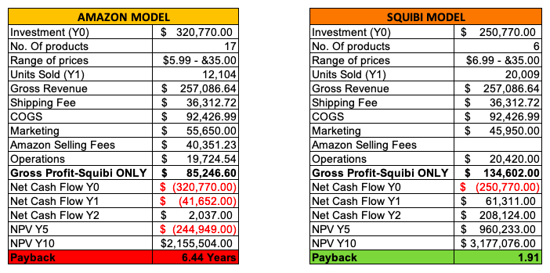

In the first scenario, we are considering Amazon as one of the main channels for distribution, sales and marketing. Setting up Squibi’s Amazon store represents a particular challenge specially because of the low price of some of the products. This ones are considered by Amazon add-ons. Meaning that you can’t order them by themselves, that have to be part of a larger order.

In the Amazon model, we are considering 17 different products, this translates into a larger initial investment. $320,000 and the forecast for units sold is lower (12,000) on the first year. This scenario involves Amazon Selling fees that round up to $40,000 and a gross profit for Squibi Only of $85,000.

This model also shows that for the first two years, the cash flows are going to be negative and it will be until Y2 that the company will begin to make positive flow.
The result for this model is a payback close to Year 7 which in most cases, it’s more than unfortunate. The Chang Family and Ian would have to sustain a company for almost 7 years before reaching payback. A scenario hard to imagine.

In the Model of Squibi setting its own website and selling from there, represents a much more realistic and optimistic scenario. Here the investment reduces since we are only producing and selling 6 different products. Sales are forecasted to be higher (around 20,000 units) with a gross revenue of $257,000. This model shows a gross profit for Squibi Only of $134,000 and a negative cash flow only during Year 0, the initial investment to start the project.

The result of this model is a payback close to Year 2. This means that during year 0 the investment would be the only negative, but after one year, Squibi would be making a considerable profit only to achieve payback a year after.

[NOTE: When all sections have been completed, click on the Table of Contents box and select “Update Table” (page numbers only) so that page numbers of the sections are in sync.]

