**Carnegie bricks**

The brickwork, of bricks stamped Carnegie, would have been constructed around the turn of the 20th century. John and James Treadwell, for whom the Treadwell Estate is named, were miners who became wealthy due to the gold of Alaska. A second mining venture was the Tesla Coal Mine, in what is now the Carnegie State Vehicular Recreation Area. It was a financial failure, but while excavating this mine they uncovered clay deposits adjacent to the mine. John and James Treadwell, went on to establish the Carnegie Brick and Pottery Company in 1903.

Many of the Carnegie bricks were used to improve the landscaping of the estate when it was owned by the Treadwell family and still edge paths on campus, as of 2018. The pottery plant burned in 1905. By 1909 John Treadwell was living in New York and James Treadwell's family was living in the house, although James was bankrupt. James died in 1916 and his son George, and George's wife Dorothy, were living on the estate by 1922 when it was bought by Meyer.

The Carnegie bricks were counted by work study, 11/1/19. As of 2019 there are 950-1200 unbroken bricks.

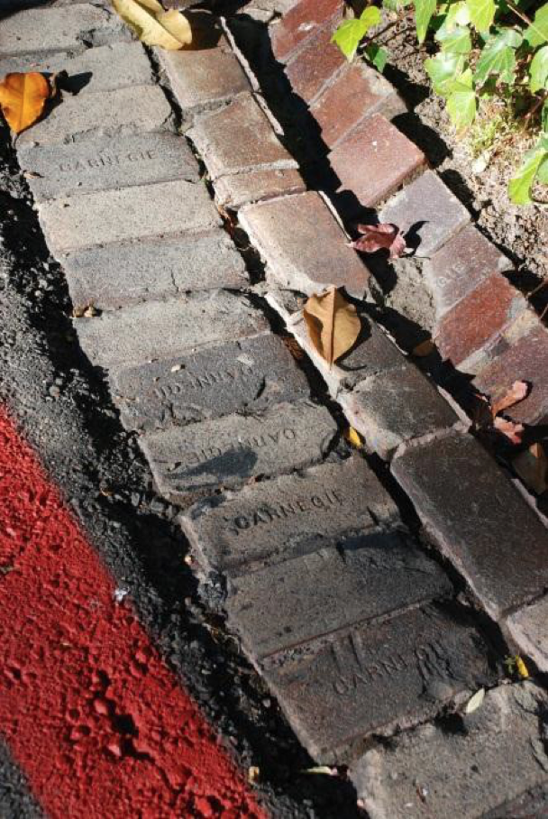 Carnegie Bricks (2014)