FINAL OPERATION PLAN

Workshop SF
Team Simple Systems
December 21, 2016

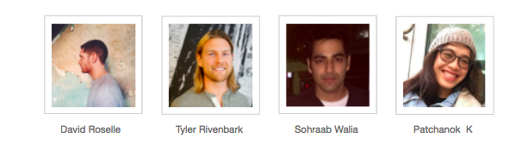

SIMPLE SYSTEMS

Simple Systems represents the future of design and foresight consultancy, by showcasing how design is shifting towards a holistic understanding and foresight is helping us see the future. Simple Systems is bringing together a balanced group of progressive, systems and design thinking practitioners who apply their knowledge through valuable methodologies. It’s a marriage between design thinking, strategic foresight and operational strategy.

EXECUTIVE SUMMARY
Introduction

Our team worked with CEO David Knight to explore possible operational initiatives through a rigorous design process. David Knight was open to new ideas but made clear there were important constraints to consider. We discovered through our participatory design process, with CEO David Knight, that he was more interested in developing new metrics around participation and building community, rather than simply increasing profit. Getting to this insight was challenging and an important pivot moment for our team to reach our current operational objectives.

The Operations Plan reviews our design process and demonstrates the final initiatives we settled on: optimizing the core business model through strategic data integration into WorkshopSF’s workflow and processes.

Short-Term Vision:

Within the next three years, WorkshopSF will increase repeat customers from 32% (current) to 45%. Repeat customers are prioritized as it is a target that best aligns with the overall mission (as opposed to increasing revenue). Creating a community through the maker culture and skill acquisition is foundational for the company.

Project Objectives:

Between 2016 to 2019:
  - Increase repeat customers to 45% overall.
  - Integrate web analytics and customer data in marketing strategy
  - Add new feedback loops to acquire insights on customer experience
  - Optimize and document business model so that it would be ready to be replicated if desired.

OPERATION PLAN TABLE OF CONTENTS

EXECUTIVE SUMMARY 2

WORKSHOP SF COMPANY 4
Client Biography 4
Mission and Vision 5

PROPOSED OPERATIONAL INITIATIVE 6
Vision Statement 6
Current Limitations 6
Operation System 8

PROCESS 13
Methodologies
STEP ONE: UNDERSTANDING THE EXISTING BUSINESS MODEL 14
Organizational Chart 14
Business Model Canvas 15
Key Financial Information 15
Touchpoint Inventory 16
Alignment Diagram 17
Service Blueprint 18
Design Process Summary 19

STEP TWO: EXPLORING POSSIBILITIES THROUGH FORESIGHT 20
2x2 Analysis 20
Recap of Operational Initiatives 21

FUTURE CONSIDERATIONS 24

RESEARCH ACTIVITIES 25

APPENDIX 26

CLIENT BIOGRAPHY
WorkshopSF is a brick and mortar organization that offers affordable DIY classes for adults, taught by awesome local teachers, makers, artists, foodies and DIY’ers. Offering over 50 classes, from the single class to multi-day classes for those who want to learn more of the craft, WorkshopSF aims to keep classes accessible for adults to learn hands on skills they can take with them. Equipped with a complete silk screening facility, basic sewing machines, WorkshopSF is focused on teaching adults new skills while also creating a fun environment to socialize in. WorkshopSF encourages you to mingle, bust out some rock & roll while you learn, and even have a beverage from the fridge. They offer classes, private events, and corporate team building off-sites.
David Knight
Co-founder,
Biz-ness operations of
workshop

Kelly Malone
Co-founder,
Teacher, DIY badass,
Interior Designer & Carpenter,
Artist & Event Planner

MISSION & VISION

WorkshopSF offers affordable DIY classes for adults, taught by awesome local teachers, makers, artists, foodies and DIY’ers. They want to expand on the great equalizer, which is an attempt to bring people from different backgrounds together and foster a community. They encourage all the students to socialize, make stuff and have a great time while learning valuable lessons.

One of the major reasons for Workshop’s success is how they deliver the experience. All the teachers at WorkshopSF are designers or makers, who are not working simply in order to earn money. They ensure that all the teachers are passionate about their classes and encourage them to promote their businesses while working, as this leads to the development of relationships with the students beyond a specific project.

Within the next 5 years, WorkshopSF plans to connect with the corporate and business community in San Francisco in an attempt to attract new consumers and expand its presence in other locations including pop-up and physical brick and mortar stores.

PROPOSED OPERATIONAL INITIATIVE

Vision Statement

Within the next three years, WorkshopSF will increase repeat customers from 32% (current) to 45%. Repeat customers are prioritized as it is a target that best aligns with the overall mission (as opposed to increasing revenue). Creating a community through the maker culture and skill acquisition is foundational for the company:
- Increase Customer Retention rate to 45%
- Double the current capacity
- Implement offsite community event

Current Limitations

Capacities
Workshop is currently at or near capacity in almost every area of the organization. With 2 classrooms which allow them to hold 2 classes at the same time, they are limited to about 30 students at a time. Each classroom is well-equipped for about 30 students. One or more classes is scheduled for almost everyday of the month, and most classes are sold out. One options is to expand their corporate events, how they do not have enough staff to execute more corporate events.
Low profit margin
After teachers are paid and supplies are bought, profit margins on each class is low, making it difficult to expand. The prices of classes are also limited because WorkshopSF wants to keep their classes accessible to the general public.
Unclear vision
When we first met with David, the vision and mission of WorkshopSF was communicated to, “Get rid of the phone and learn how to make stuff and be the Great Equalizer.” The “Great Equalizer” is valuable emotional driver, but the overall vision and mission is not clear to guide action and give direction.

Data Collection:

The current method for collecting data on consumers is informal and cannot be extracted easily. They collect data via a platform called E-Tix, which is also where customers purchase their tickets for WorkshopSF. E-Tix does sort their data but our client feels like it is not the most efficient methot of data aggregation.

Lack of process documentation and evaluation

“You cannot improve what you cannot measure”

Currently, WorkshopSF processes are undocumented, creating difficulty in their ability to reach future goals, like expanding. The informal, undocumented and organic nature of their organizational processes has created an organization that relies heavily on its three main staff members, David, Kelley and Halley. This has created a difficulty in communicating processes to potential new employees. They are currently at a level 2 organizational maturity, with the potential to improve but a lack of process documentation and evaluation hindering their growth.

Operations System
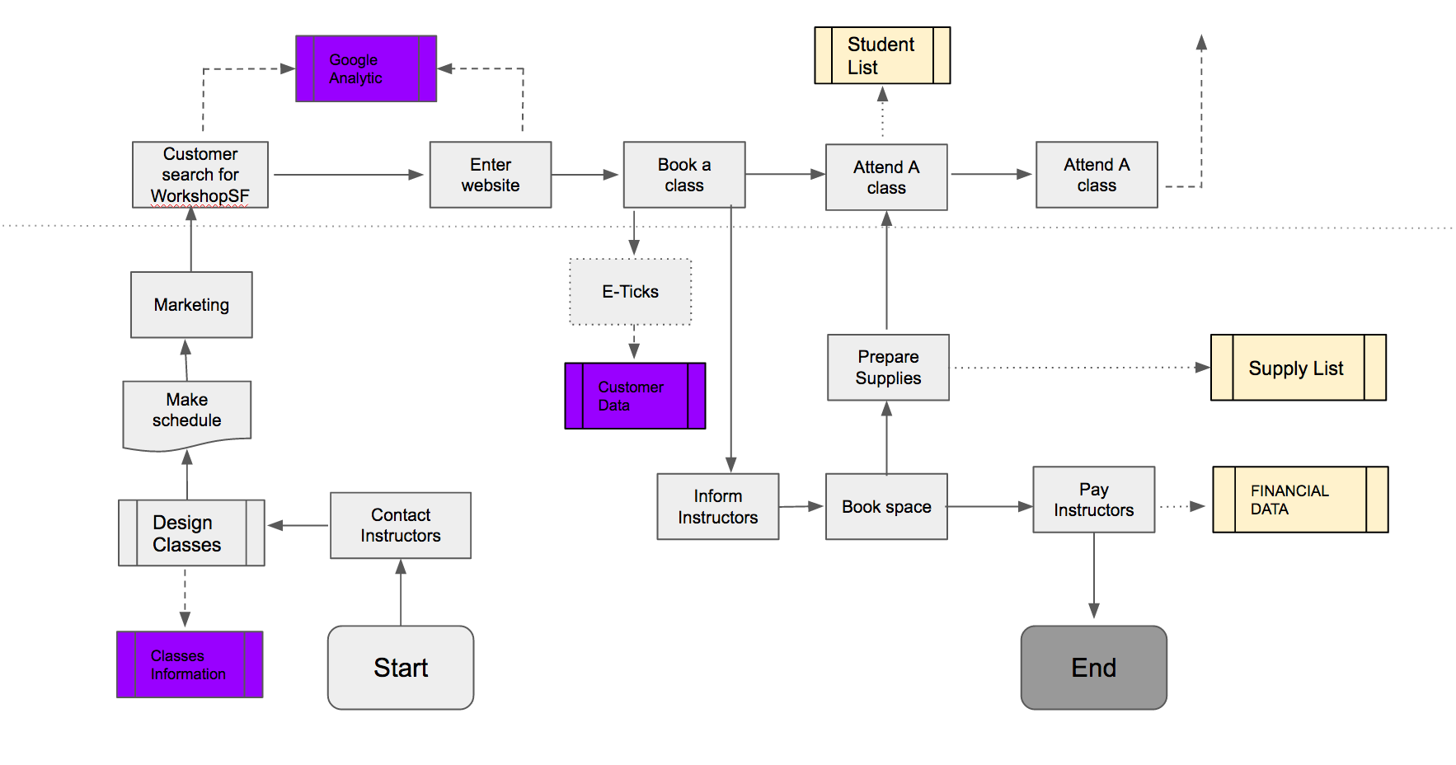
Process Mapping

Once we set our operational initiative to focus specifically on the core operations, we made a process mapping diagram to understand how all the processes connect together. Highlighted in purple, we identify data sets to that are underutilized. This includes: class information, google analytics and customer data.

In working with David, we learned these raw data sets are not used for decision-making. These three data sets became imperative to develop our operational initiative. We spent time analyzing data sets to uncover key behavioral insights David could benefit from in his classes. He stressed the importance to find out how many repeat customers there are.

Customer Retention

Returning customers became our north star for the operational initiative. It is an interesting metric because it requires more thoughtful analysis on a customer’s experience. What will make someone come back? In order to answer that question, we recognized the important to know how many are coming back in the first place.

In order to respect our client’ confidential data, we cannot exhibit the financial analysis we conducted.

After analyzing a sample set of 2,000 raw data points on customer transactions, we uncovered a 32% repeat customer rate. 23% came more than twice and 3.25% came more than four times. This established a benchmark for us. With this information and talking with David, we set our goal for repeat customers to reach 45% in three years.

It’s important for us to make note that we came to this operational initiative within the last two weeks of our design process. If we had more time, we would have explored more data analysis to learn about customer behavioral patterns. We considered factors like: average time class is booked, most popular classes, most lucrative classes, seasonal classes as well as introducing new data points to acquire, like a simple set of emojis to select after class. We would have continued to explore more insights data would yield about WorkshopSF customers.

Google Analytics

WorkshopSF attained Google Analytics as a monitoring tool for their website 2 years ago. It has given them insights on:

- Websites that are directing traffic towards them
- Keywords that potential consumers are using to find WorkshopSF
- Monthly metrics on webpage views
- Geographic tagging of website visitors

This data is very useful, but it seems that they are not utilizing it to its full potential. The main reason for this issue is that David does not know what he should do with the data once he has acquired it. We believe that if we organize David’s sales and web data and design suitable metrics for success around them, he will be able to act on the data more effectively.

Key Process Indicators:

KPIs are business metrics that are used to evaluate factors that are crucial to an organization’s success. These indicators can have several metrics, ranging from customer loyalty and customer lifetime value metrics to sales and web traffic metrics.

The platform that we have chosen is called Klipfolio. It allows users to design several dashboards, each comprising of several KPIs which may be pre-designed or custom built by a company such as WorkshopSF to cater to their data. This website allows users to integrate data from Google Analytics, Salesforce, Social Media, etc. which makes it easier for companies to adopt it. Currently, WorkshopSF has Google Analytics which serves as a web traffic source and they have E-Tix which is an online platform that allows them to monitor the sales of their tickets.
Our client mentioned that while E-Tix monitors and organizes their data, they do not know how to act upon it. Therefore, one of our early recommendations is to adopt Salesforce in favor of E-Tix as it will allow WorkshopSF to aggregate all their data on a single platform such as Klipfolio.

The main advantage of this platform is the option of creating dashboards. The Google Analytics dashboard on Klipfolio consists of all the data Google Analytics monitors and represents them via KPIs specific to each category. Once the user has set up their KPIs, they can start to extract trends by analyzing the relationship between specific KPIs on a dashboard. For example: The Customer Lifetime Value KPI offers insights on the purchasing behavior of a consumer over the years, and the email engagement and web traffic sources

KPIs monitor the source of consumers for a company. We can use the data from these sources to develop insights such as why certain regular customers are returning to a brand even though they do not engage with the brand’s marketing efforts. This in conjunction with other KPIs can be used to identify the main appeal of a brand to its customers, an insight that most companies can never attain.

We believe that WorkshopSF can benefit greatly from Key process indicators. As mentioned earlier, one of David’s main problems is that he cannot act on the data he has due to a limited understanding of what the data represents and how it can potentially impact his business. Once he extracts trends from the data, he will notice that the data he has collected over the years does in fact have tremendous value, even if it may seem intangible.

The following is a list of KPIs that we have recommended to WorkshopSF:

- Customer Lifetime Value

It measures the amount of money a customer brings in over the entire time they do business with a company.

- Web Traffic Source

Measures which traffic sources are driving visitors to your website, and provides a comparison of each of those sources.

- Product Performance

It ranks product sales based on revenue performance to inform your sales team which products are selling well. At the same time, it also ranks the poorest performing products to determine which products are failing to resonate with customers.

- Purchase Funnel

The purchase funnel is typically broken down into five stages: awareness, interest, consideration, preference, and purchase. The key to the purchase funnel is analyzing conversion rates from one stage of the funnel to the next. The strength of the funnel is the ability to zero in on your strengths and weakness.

- Sales Growth:

It measures the pace at which your organization's sales revenue is increasing or decreasing. This is a key metric for any organization to monitor since it is an essential part of growth projections and is instrumental in strategic decision-making.

Recommendations

Below are a set of recommendations for WorkshopSF to consider for our operational initiative.

Potential ideas for expansion
- Hire an intern/part time employee [management, digital marketing, corporate events, etc.]
- Rent a temporary space. Test out the concept in new spaces to identify new markets.
- New channels for marketing. Utilize social media for businesses
- Membership benefits for VIPs.
- Engage in after-class activities. [Develop student-teacher relationships by hosting mixers]

Develop Customer Feedback Process
- Customer interview guideline
- Leverage technology for the purpose of customer experience

Implementing Klipfolio
- 5 starter Key Process Indicators
- Establish benchmarks for success via metrics such as goal completion.
- Link all of the information to Klipfolio and establish it as a central platform for analyzing data.
- Update and refine KPI metrics yearly
- Integrate Salesforce

PROCESS
Methodologies

We deployed multiple strategies throughout the project in order to yield the most useful results for David. We engaged in a deep, meandering design process which required us to pull back the curtain to all major processes in the company. We used foresight tools like scenarios, 2x2s, and three horizon frameworks to consider future possibilities. Lastly, we utilized insight from The Process Improvement Handbook to craft and document the existing processes.

- Design
- Foresight Frameworks
- Operational Strategies

STEP ONE: UNDERSTANDING THE EXISTING BUSINESS MODEL

Our first step in our design process to fully grasp the existing business model. We believe this was critical in order for us to imagine new operational initiatives that would successfully integrate. This section will cover various toolsets used to document existing processes. Working closely with David, attending classes, and researching all allowed us to get a clear picture on how WorkshopSF operates.

Organizational Chart

At the onset of working with David, we knew the organization would function differently than a typical store. He split the work with one cofounder, Kelly, and a part-time staff member, Hailey. There wasn’t a set rubric instated for business processes. Business roles were defined organically and informally that relied on an intuitive understanding for all staff to be on the same page. The three share a passion and determination in the vision to execute every day.

Now while simply standardizing seems like it would be a logical solution to impose, their informality is representative of their ethos. They are not a stiff and pretentious educational environment; instead, they prioritize creating a safe space for all participants. This challenges us as designers to ensure we prioritized the character of the operations while still optimizing their performance.
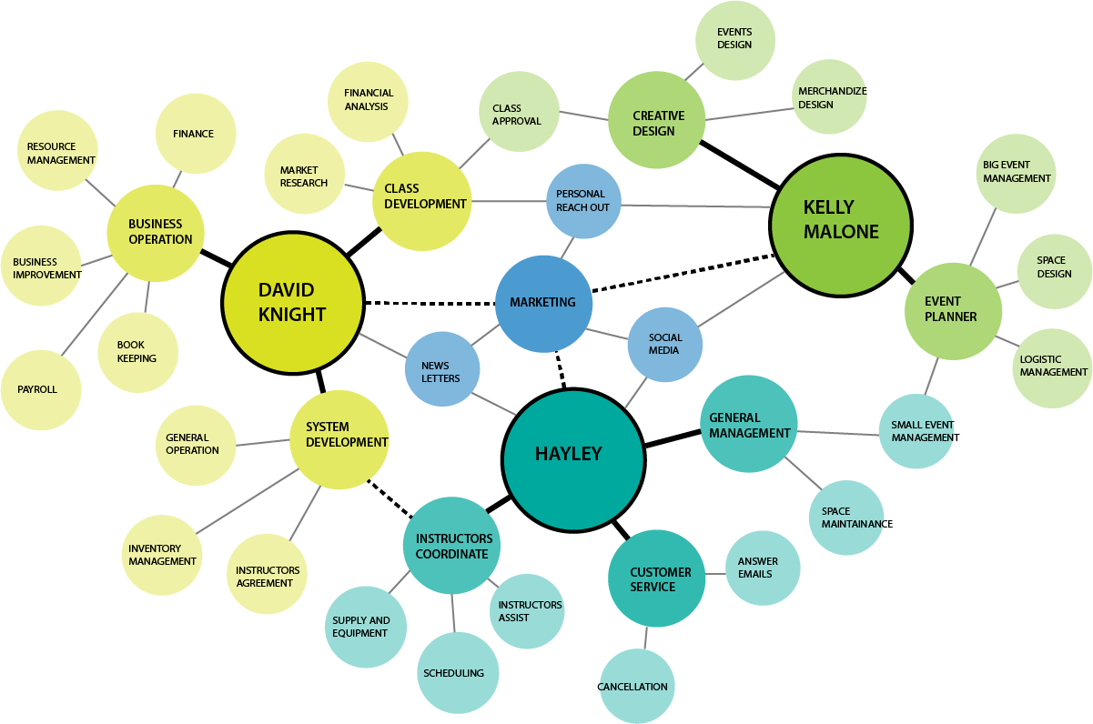

Business Model Canvas

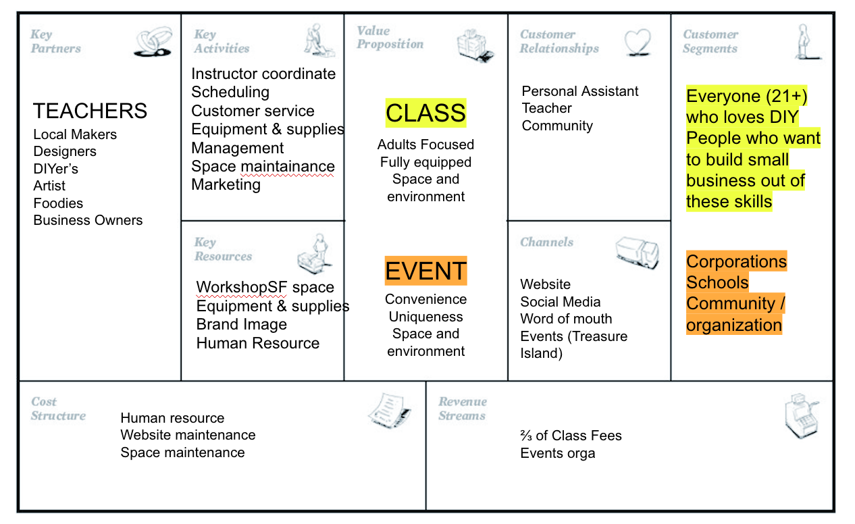
The Business Model Canvas helped us to define more clearly the product and the value proposition. More than merely a skill-development class, customers attend classes for the overall experience. It’s fun, light and engaging. Other important insights the BMC revealed are: instructors play critical role as key partners, there are two customers bases, there is no formal marketing strategy, and more revenue comes from corporate events than DIY classes.

Key Financial Information (Estimation)
Revenue:
DIY Classes
50 different classes offered.
40 class scheduled per month
$40 - $100 per class
320 - 380 tickets sold per month
$16,000 - $19,000 revenue per month

Corporate Events
~$20,800 revenue per month

Expenses:

Variable costs:
⅓ of revenue to instructors
⅓ of revenue to inventory
Fixed Costs:
$5,000/month fixed costs per month

Net Revenue:
$5,300 - $6,300 net revenue per month DIY
~$6,900 net revenue per month Corporate
$7,200 - $8,200 total net revenue

Touchpoint Inventory

WorkshopSF doesn’t use a marketing strategy so understanding how customers find out about classes was an important question to us. They don’t have a developed marketing strategy because capacity is maxed out and they aren’t able to house the increase in demand. We used the touchpoint inventory to evaluate all the ways their brand interacts with the general public.

We learned that the brand, while successful, can be more resonate in certain environments. One identified problem was reaching networks outside of the art community. Moreover, getting repeat customers also is a challenge. This showed us there is room to improve their digital marketing, which includes understanding their customer base better.

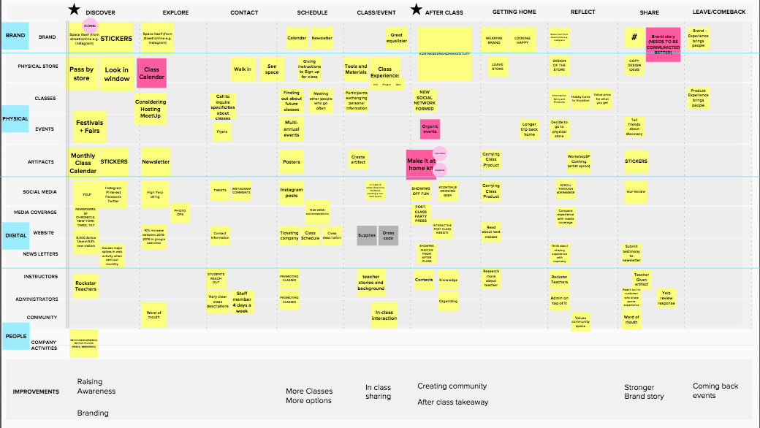

Alignment Diagram

The alignment diagram is a helpful tool to understand the different stages a customer experiences with WorkshopSF. Many of them often go unnoticed which makes the Alignment Diagram useful in defining the various stages. Overall, we identified nine stages for the customer experience. Two stood out as noteworthy.

The discover stage is noticeably undeveloped. Most customers interact with WorkshopSF serendipitously, often times at Treasure Island Music Festival.

The after class stage is ripe for innovation. As Tyler and Pow learned from attending class, many people are in a great mood once class ends. Yet, nothing is there to capture participants excitement so many people just go home. The end of class feels anti-climatic.

Both insights inspired us for prototyping an operational initiative which we will share later in the document.

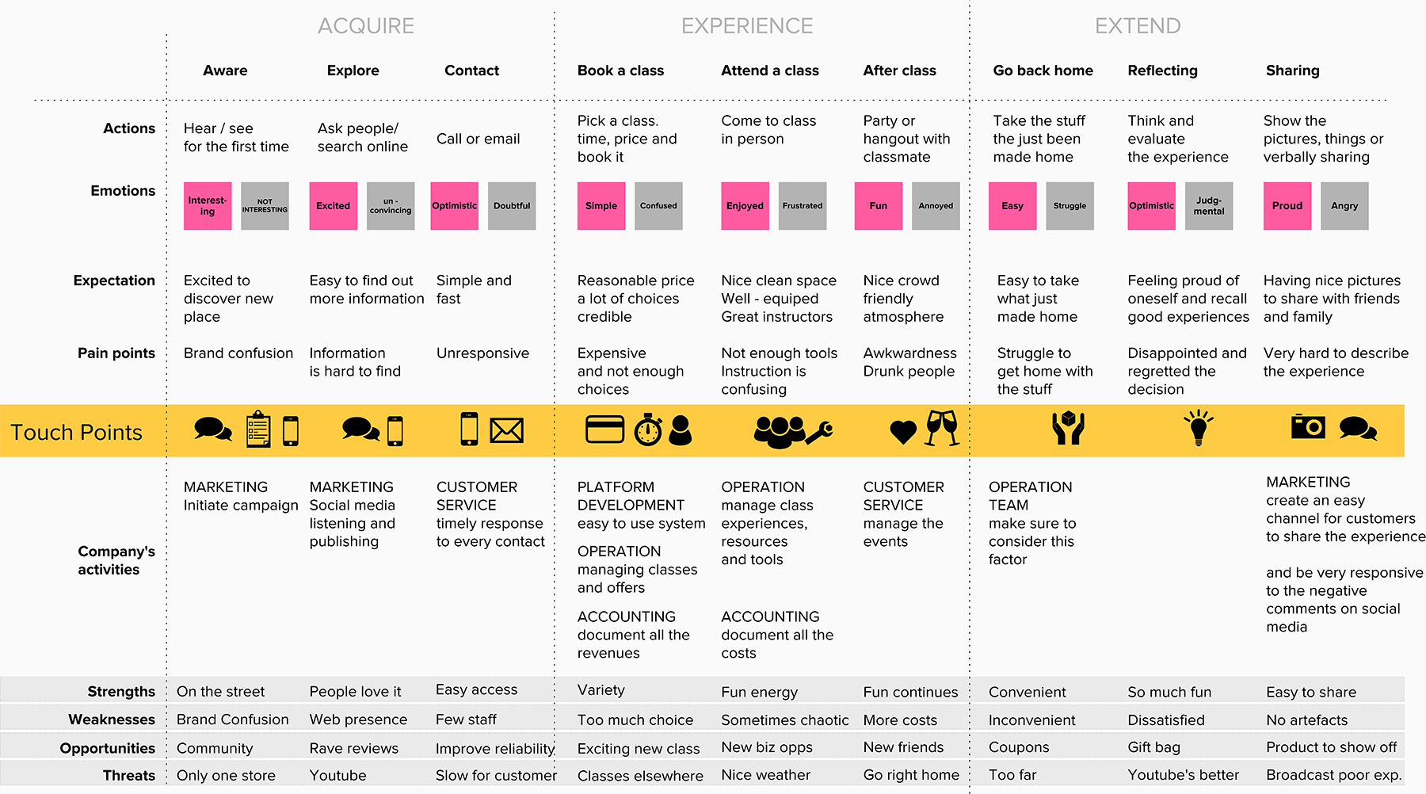

Service Blueprint

The Service Blueprint served as a way to evaluate the current operation process. After our assessment, we determined the operation process to be at Maturity Level 2. Data documentation is disorganized. There aren’t any established processes in place. Instead, they use a feelings-based approach. Moreover, there is no support after class experiences.

Key Information
- 40 Classes per month with maximum 2 classes running at the same time (due to the limitation of spaces)
- 60% of revenue comes from corporate events
- 40% of revenues comes from classes
- Use E-Ticks as a ticketing platform which record customers’ tickets statistic
- Instructors has is the biggest touchpoint that affects customer experience
- Class equipment and supplies cost approximately one-third of the cost of the tickets
- Class equipment and supplies are loosely controlled and document.
- Each instructor buy their own equipment for class, with receipt WorkshopSF pay them back later
- Google Analytics has been the main tools for data analysis.

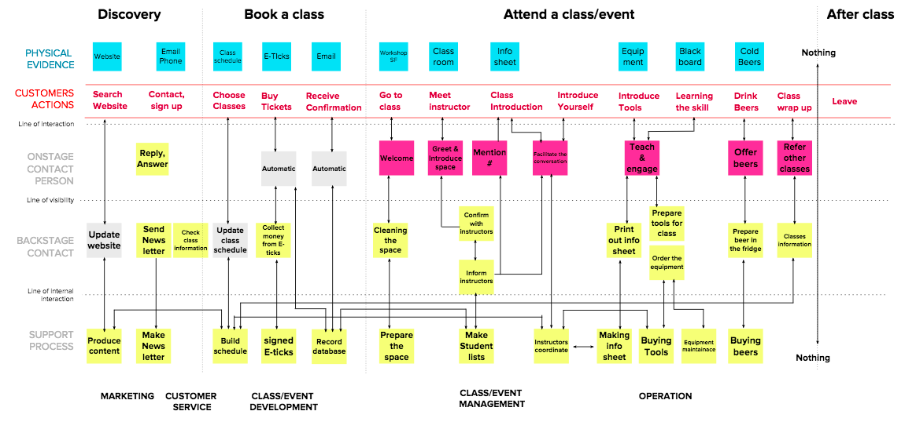

Design Process Summary

After going through an extensive design process to understand the existing business model, we concluded there are four major pain points:
- Limited Capacity
- Low Profit Margin
- Brand Awareness
- Lack of Documentation

STEP TWO: EXPLORING POSSIBILITIES THROUGH FORESIGHT

Strategic Foresight is an effective tool to complement the design process. Foresight provides the techniques to evaluate future possibilities. It does so through establishing the cone of possibility then narrowing between plausible and preferred futures. The process requires the user to truly consider the direction they are heading so that it can leverage the power of intention.

Throughout the design process, we encouraged David to imagine the future for his business. We didn’t want to get stuck in the minutiae of practicality so we pushed him to think outside the box. We deployed the three horizons method to consider the simultaneous management of three horizons: the present (>1 yr), the near future (3-5 yrs) and the distant future (5-8 yrs).

Consequently, this enabled us to develop four operational initiatives. Presenting these initiatives were critical for us to arrive at our final operational initiative. By exploring the depths of possibility, we knew, over time, because of the constraints, that we would be more effective if we abandoned the near and distant future and focused directly on the present. Rather than expand boundaries, we tightened the core operations.

2x2s: Axis Analysis

2x2s are a useful tool to define tensions within a particular subject matter. After intersecting two spectrums, a 2x2 will help to illuminate underlying relationships. The 2x2 below was imperative in our development of operational initiatives. We identified corporate + teaching and in-person + extrovert as key demographics to analyze. Do people rather come to class to have a good time or to learn a skill? And does personality play a role in which kind of customers would attend? These questions gave our design process more texture while developing our operational initiatives.

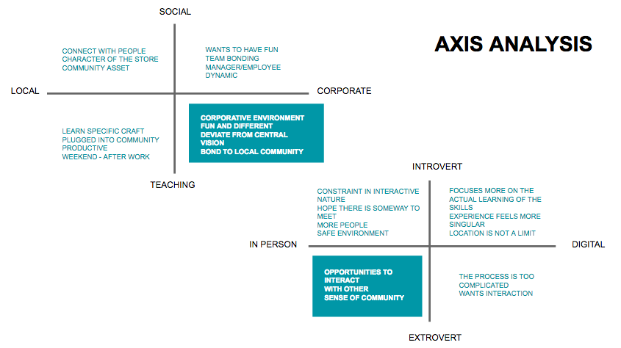

A Recap of Operational Initiatives

Our final operational initiative ended on an important yet straightforward solution. It is important to understand that our design process took us far from the core model which allowed us to realize the core operations should be prioritized as the primary initiative. To review our design process, read through the four, proposed initiatives as well as an explanation to why they were unsuccessful.

Operational Initiative #1: Corporate Events Branch

The primary initiative will incorporate more structure to an existing strong revenue stream: corporate events. While this market slightly deviates from the heart of WorkshopSF—the community--corporate events are a consistently strong revenue stream that supports the socially-rich yet fiscally weaker community side of the business. By taking a more direct approach to corporate events, WorkshopSF can expand their business model exponentially to become the go-to organization for team building and skill sharing facilitation. This business arm should become experts in understanding the pain points corporations have for team building and how a mobile WorkshopSF can fill those gaps.

Unsuccessful: Despite feeling this was our strongest initiative, David lead us away from working on corporate events. He said his business partner, Kelly, is an expert at event planning so it wouldn’t be worth our time developing corporate events. It was surprising to us because corporate events were poorly documented as a process so it seemed logical that the most successful part of his business could benefit from more documentation. Nevertheless, it was helpful for us to learn where he wanted us to focus.

Update: A few weeks after we shared with David the corporate events initiative, he went ahead to further develop it out himself. He put together a 20-page document that outlines the scope of work for corporate strategy. He credited us with providing him the initiative to develop the document.

Operational Initiative #2: Recital of Classes

WorkshopSF currently offers an abundant variety of classes to customers. However each class operates as a stand alone class; they are not connected to each other over a period of time. From our customer’s research, the current in-class experience was very positive, but we noted the momentum of experience ended right after class. We also noted customer’s shared their personal goals at the beginning of class, some of which were very ambitious. WorkshopSF should consider offering a bundle of classes that ends with a recital as a way to incentive continual learning in order to reach each customer’s personal goal.

Unsuccessful: David understood the idea for developing a bundle of classes together but he shared he was pessimistic they would be well-attended. He explained customers are actually fairly unreliable when it comes to attending multiple classes. So if he designs a set of classes that require a prerequisite, he fears they would be poorly attended.

Update: David shared with us towards the end of the project he thought more about the bundle of classes and in certain instances, he said they would work well. He ended up going ahead and designing a few classes together so that people could build on their work from the prior class. He credited the idea to us but still preferred us to focus on the final operational initiative.

Operational Initiative #3: Local Business on Tap

WorkshopSF is one step away from creating a large, thriving and loyal community that will allow WorkshopSF to expand to the next stage of its development. After attending a class, we noticed that there was a buzz in the room that could be tangibly felt. We noticed that customers had a desire to hangout more after class, and the limited space and time that a WorkshopSF class provided was not enough. We also conducted extensive market research, and it became apparent the cultivation of community is a market viable product. Not only does it appeal to a mass market, but it has healing properties for isolated, anonymous communities members. With the influx of many, new workers in the Bay Area, social isolation has become problematic. There are few urban touch points socially isolated individuals value to engage with to meet likeminded people. This operative initiative also allows WorkshopSF to expand its capacity to host more students and increase local awareness.

Unsuccessful: David appreciated our attempt to capitalize on after-class time but he disliked the proposition of working with businesses in the area. He didn’t want to be tied into an obligatory agreement with other businesses. Nor did he see enough incentive to go through the effort to develop a set of venues to attend after class. Instead, he saw a bigger opportunity in occasionally hosting parties in the space after class to keep the energy going.

Operational Initiative #4: Offsite Community Events

After receiving feedback that the corporate events branch was too corporate and therefore inharmonious with brand’s intention, we developed an initiative that would cater to his primary audience: the people of San Francisco. We wanted the tone of this initiative to feel more aligned with the brand experience and of events like Treasure Island Festival. We focused on a new event space because space limitations posed a significant obstacle in developing a new strategy. This would successfully allow WorkshopSF to reach more customers without buying a new space.

Unsuccessful: The initiative didn’t work because it would ultimately require too much new operational development when the staff is already overloaded. David made it clear after a few months working together he was not interested in hiring another staff member. Even though we proposed the new initiative would bring in enough revenue to justify a new hire, David decided against moving ahead with it.

FUTURE CONSIDERATIONS:

After our team directly engaged with WorkshopSF’s community and classes, it is clear there is a tremendous amount of potential in this company. Customers are receiving meaningful experiences through WorkshopSF’s classes, and they want to engage more.

Creating meaningful customer experiences are the most valuable products of the 21st century, and WorkshopSF has great potential to expand past its single brick and mortar shop. David is a great leader, whose integrity will keep WorkshopSF a company that sticks to its core values. David, also has shown limitations as a leader, through a lack of ability to create structures to support the growth of his community and not wanting to use proven methods to increase profit and support the expansion and furtherment of his company and values. WorkshopSF fills a meaningful spot in many people’s lives, as urban citizens look to connect with each other in fun ways, WorkshopSF fills the role as the great equalizer.

With a potential to expand across the country and beyond, it difficult to see this with David’s current mindset. We feel David, needs to take a leap in the evolution of his thinking and the refinement of his vision to take WorkshopSF to the next level. On WorkshopSF current track along with the work we have done, we see WorkshopSF moving forward in a practical and documented fashion, while increasing customer retention.

RESEARCH ACTIVITIES:

Our team went through a long and rigorous series of research activities. Kicking off our project with a workshop with our client, David Mcknight, co-creating a journey map and the beginning of our alignment diagram through our participatory design process. We engaged with our client on a close to weekly basis to build a relationship and co-creative process to develop our initiatives, making sure that our work was what our client wanted.

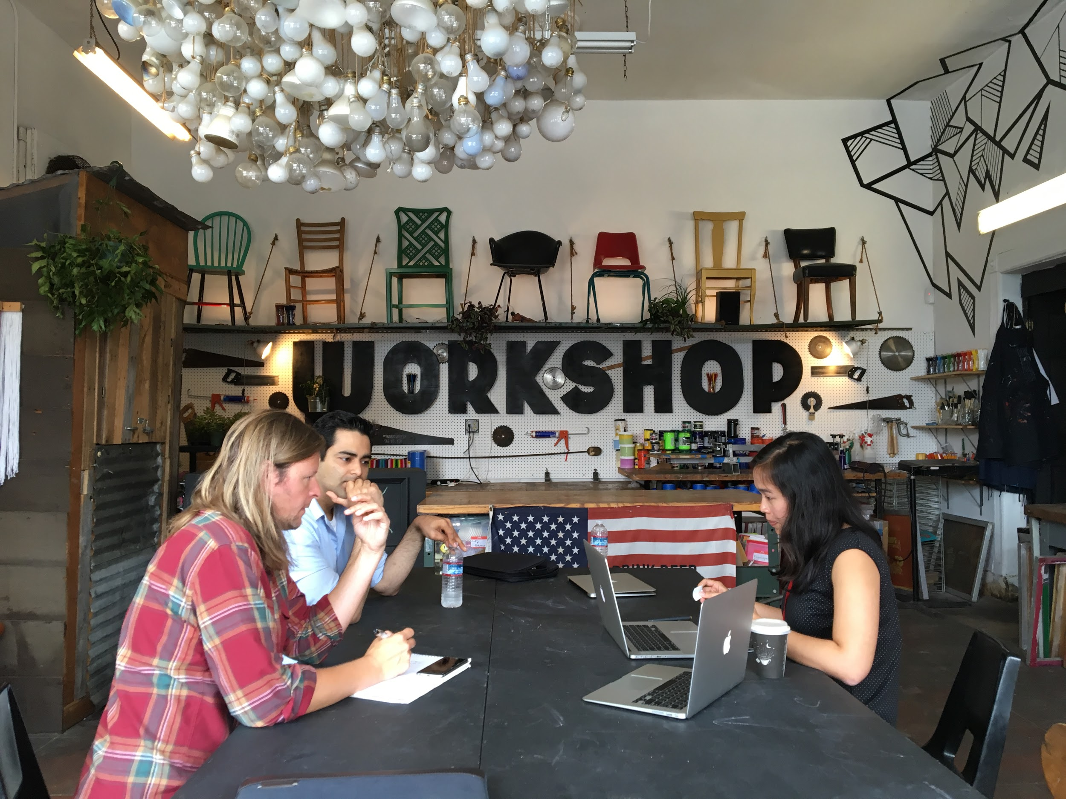
One our most valuable research activities was a contextual inquiry activity, while attending a class, full participating and interviewing customers. We learned a great deal about the WorkshopSF experience, including how strong the class experience is in people's lives, and how big the opportunity is to extend the WorkshopSF experience.

Our contextual inquiry process, started by arriving to our Sewing 101 class early to create rapport with Halley, the teacher and third employee of WorkshopSF. We were set up with all of our sewing equipment and started asking questions to customers about their experience, learning every detail from how they got to class, to how they liked each project and how it was to end class. One customer even tried to stay to drink more beer while we were interviewing Halley about her process, assessment of the organization and how she sees WorkshopSF can improve.

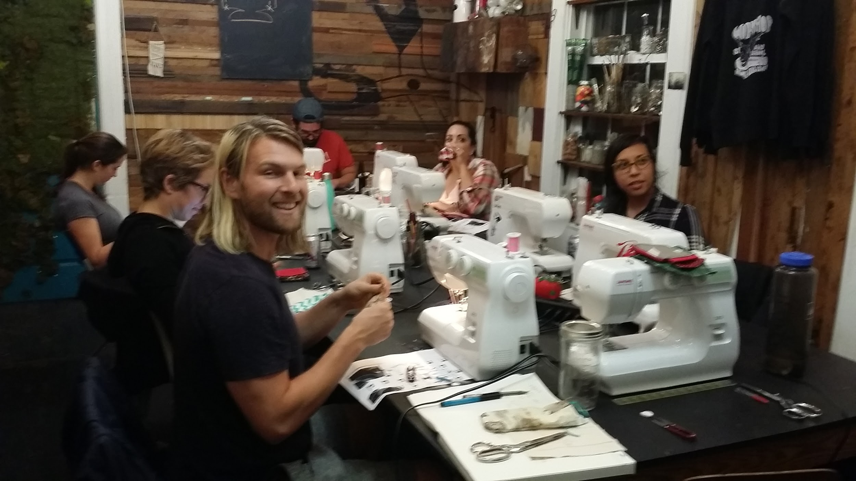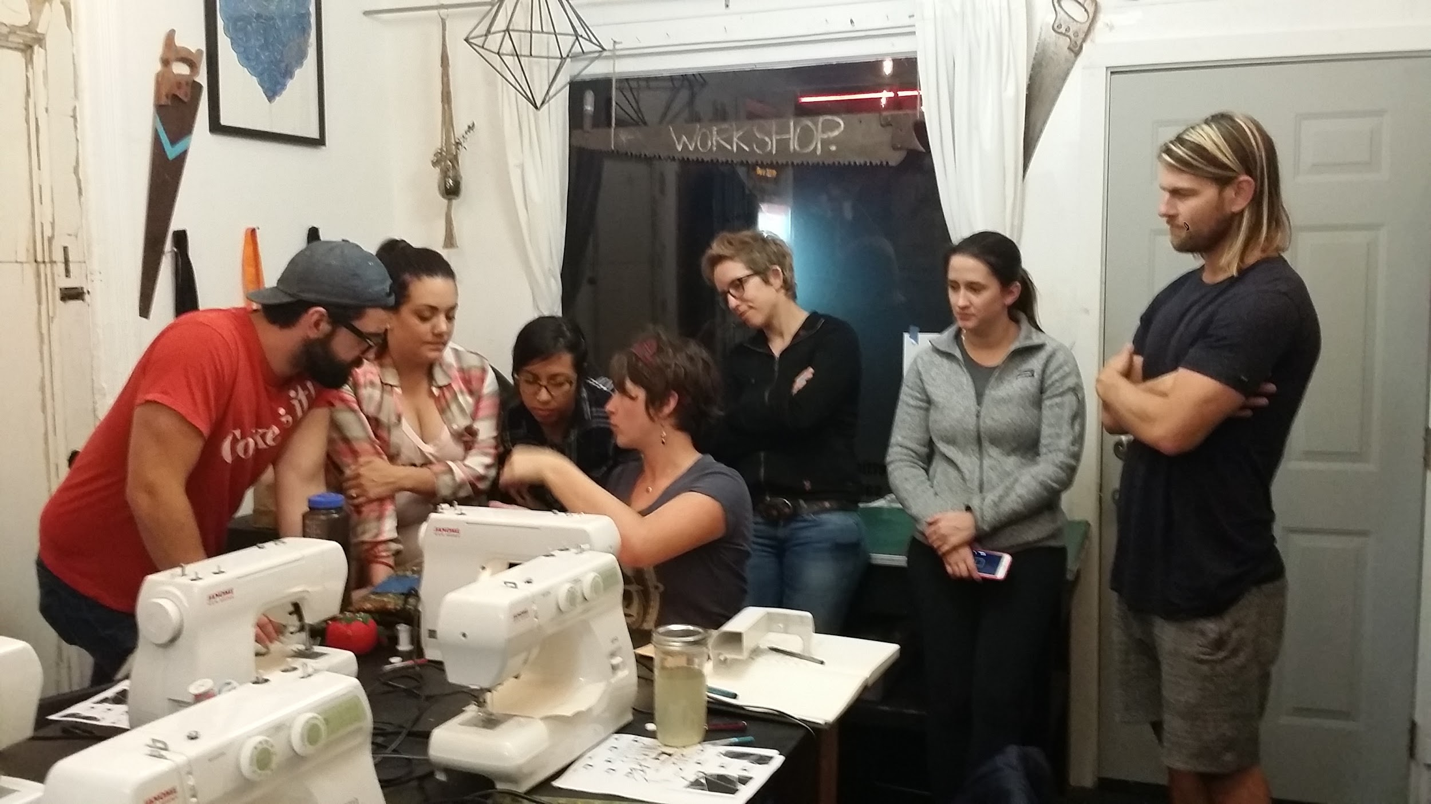

- APPENDIX

EXHIBIT 1 : ALIGNMENT DIAGRAM

EXHIBIT 2 : CUSTOMER RESEARCH - ATTENDING SEWING CLASS
Kalley explains to the class the components of sewing machine

Class atmosphere was very relax, 5 out of 7 people had a beer

EXHIBIT 3 : WORKSHOP SF CLASS SCHEDULE FOR SEPTEMBER

EXHIBIT 4 : STRATEGY BLUEPRINT
