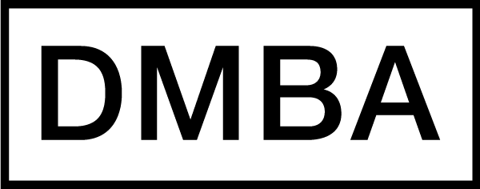

Final Project Summary
PURPOSE: The final project summary provides material that may be published to help promote the impressive work product of DMBA students and the program in general.

Project Title: | Cha-ching! Chipotle
DMBA Course Name: | Managerial Accounting
Semester (e.g., Fall 2013): | Fall 2015
Team Project (Yes or No): | No
Student Name: | Rebecca Luoh
Student Name (if applicable):
Student Name (if applicable):
Student Name (if applicable):
Student Name (if applicable):
Student Name (if applicable):
One sentence description: | A look at Chipotle's annual report from 2014.
2-4 paragraph description: | I analyzed Chipotle Mexican Grill's financial statements from 2013 - 2014. Looking at the balance sheet, income statement, and cash flow statements, I found out some interesting things about the company and overall health of CMG.
Image #1 depicting the project:
(highest resolution possible, please)
Image #2 depicting the project: (highest resolution possible, please)
Image #3 depicting the project: (highest resolution possible, please)
Does your project involve a Mutual Confidentiality and Nondisclosure Agreement with a client? (Yes or No) | No
Are there any issues with public publishing of your description and images? (Yes or No) | No

INSTRUCTIONS: The owner of the course project, or one member of the team, will fill out this summary based on the final project deliverable and upload the document to Moodle under the assigned course. Please upload as a Word file (not a PDF). Contact your instructor or Associate Chair if you have any questions.

