Final Project Summary
PURPOSE: The final project summary provides material that may be published to help promote the impressive work product of DMBA students and the program in general.

Project Title: | Petsmart Accounting Final
DMBA Course Name: | Financial and Managerial Accounting
Semester (e.g., Fall 2013): | Fall 2015
Team Project (Yes or No): | No
Student Name: | Min Jung Kwak
Student Name (if applicable):
Student Name (if applicable):
Student Name (if applicable):
Student Name (if applicable):
Student Name (if applicable):
One sentence description: | I analyzed the Petsmart's financial statements and ratios to see if the company is financially stable and efficient.
2-4 paragraph description: | Petsmart is the largest pet supply retailer in North America so I expected its financial to perfom outstandingly. The income statement show that the revenue was increasing over the years but the cash flow statement revealed that the company's cash income was decreasing. However, the financial ratios showed that Petsmart was performing better than the industry's avarage, which shows that the company is not highly efficient but it is financially stable.
Image #1 depicting the project:  (highest resolution possible, please) | 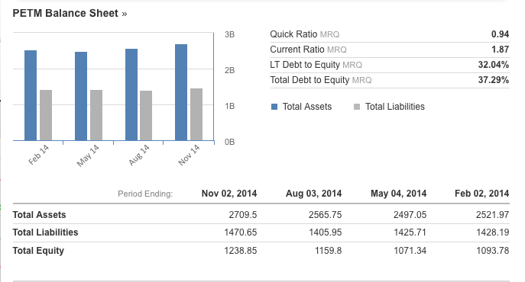
Image #2 depicting the project: (highest resolution possible, please) | 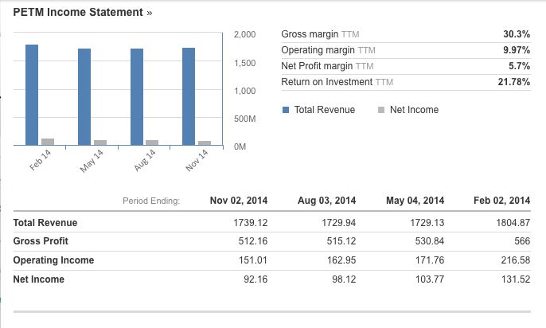
Image #3 depicting the project: (highest resolution possible, please)
Does your project involve a Mutual Confidentiality and Nondisclosure Agreement with a client? (Yes or No) | No
Are there any issues with public publishing of your description and images? (Yes or No) | No

INSTRUCTIONS: The owner of the course project, or one member of the team, will fill out this summary based on the final project deliverable and upload the document to Moodle under the assigned course. Please upload as a Word file (not a PDF). Contact your instructor or Associate Chair if you have any questions.

