Final Project Summary
PURPOSE: The final project summary provides material that may be published to help promote the impressive work product of DMBA students and the program in general.

Project Title: | Yelp the Bilion Dollar Bully
DMBA Course Name: | Financial & Managerial Accounting
Semester (e.g., Fall 2013): | Fall 3015
Team Project (Yes or No): | No
Student Name: | Caroline Dando
Student Name (if applicable):
Student Name (if applicable):
Student Name (if applicable):
Student Name (if applicable):
Student Name (if applicable):
One sentence description: | Analysis of 2015 Q3 financial statements for the review site Yelp.
2-4 paragraph description: | For the financial and managerial accounting final I was as asked to prepared a narrated presentation using the knowledge gained from the semester to analyse a publicly traded company of my choosing.  My analysis was performed on the 2015 Q3 earnings release of Yelp, the (in)famous review site. I used the income statement, balance sheet and statement of cash flows to calculate various rations that are can be used to delve into the financial state of the company.  What I found was that although they have steady year on year growth, and a good compounded annual growth rate, they are making a net loss with falling operating profits, a low return on equity and poor free cash flow margins.
Image #1 depicting the project:  (highest resolution possible, please) | 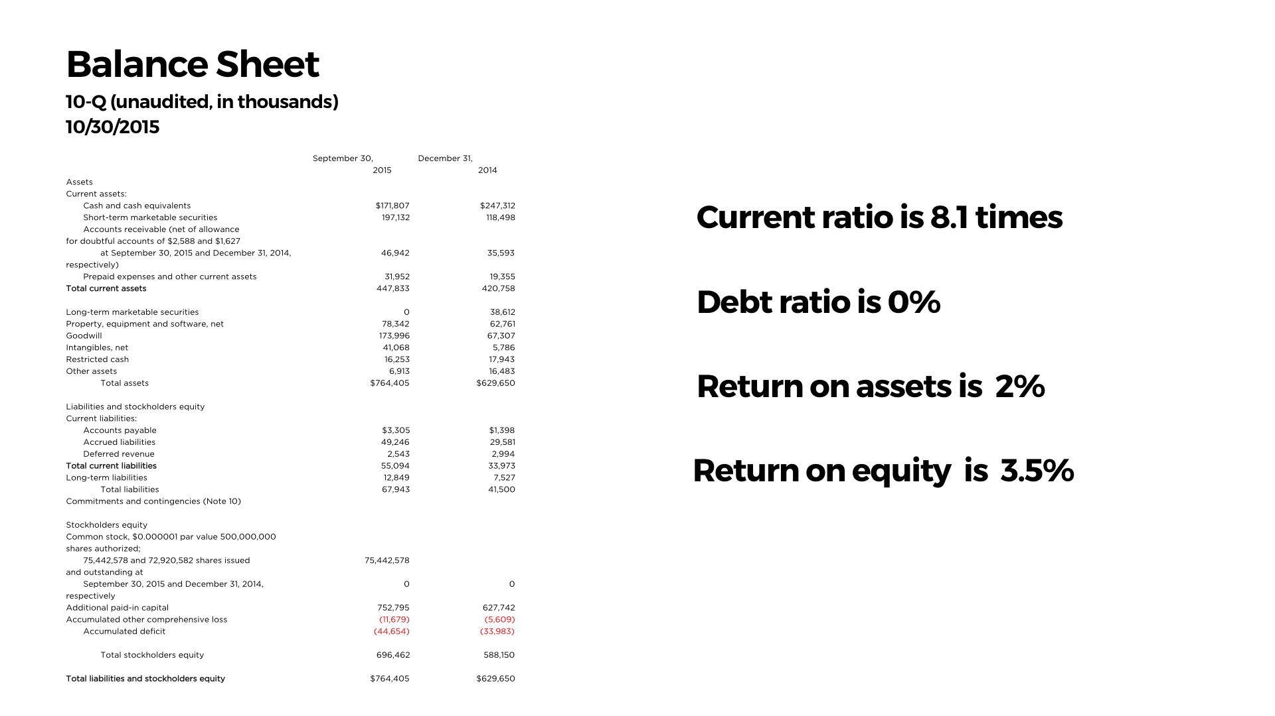
Image #2 depicting the project: (highest resolution possible, please) | 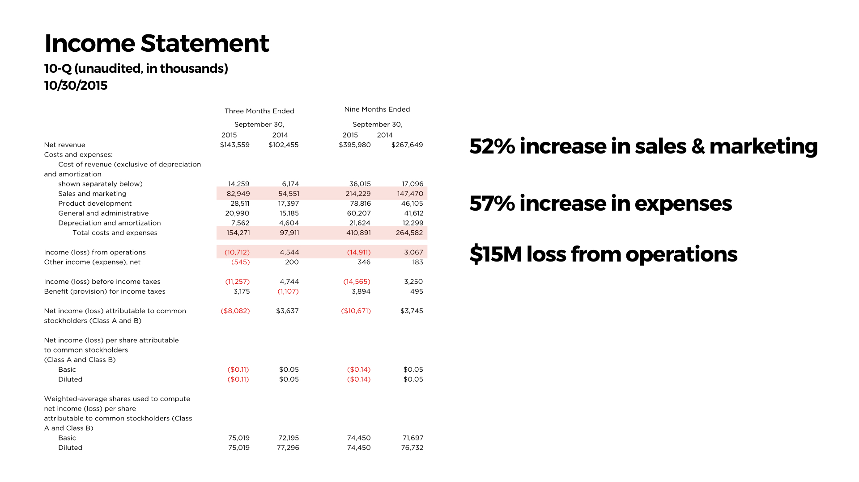
Image #3 depicting the project: (highest resolution possible, please) | 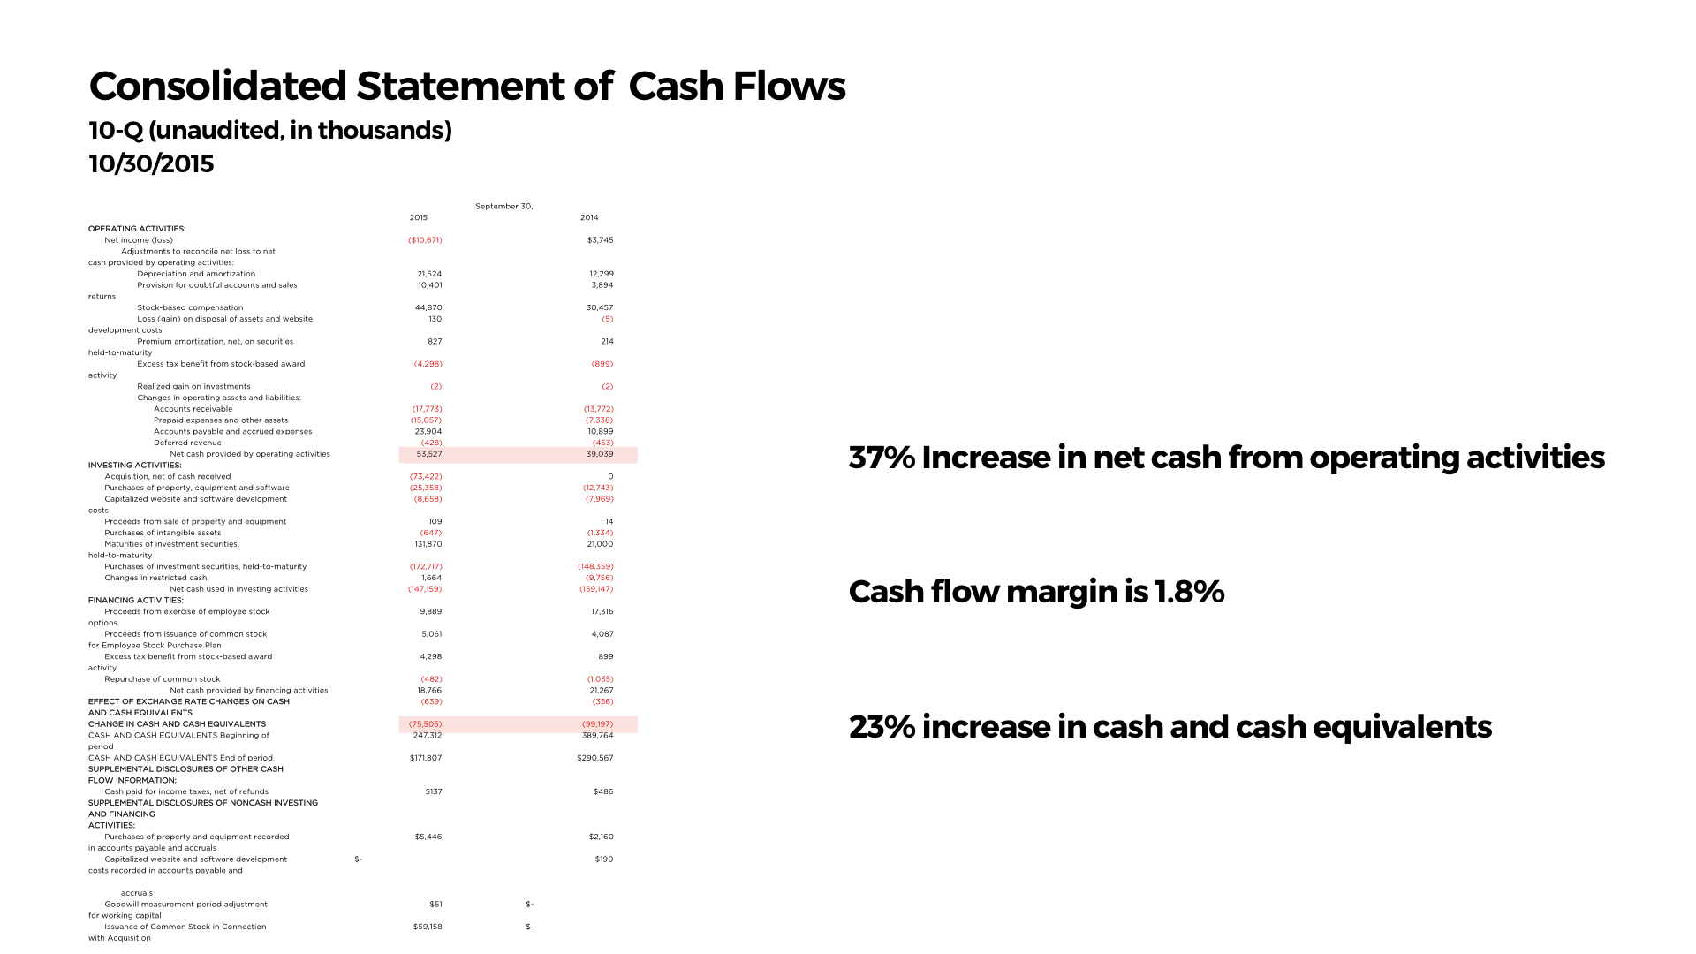
Does your project involve a Mutual Confidentiality and Nondisclosure Agreement with a client? (Yes or No) | No
Are there any issues with public publishing of your description and images? (Yes or No) | No

INSTRUCTIONS: The owner of the course project, or one member of the team, will fill out this summary based on the final project deliverable and upload the document to Moodle under the assigned course. Please upload as a Word file (not a PDF). Contact your instructor or Associate Chair if you have any questions.

